Self-Directed Learning – Week 1

The graph below shows most food losses occur early in the food supply chain for low-income countries but late in the chain for high-income countries. Think about some of the reasons for this trend, complete the summary table, then copy it into your journal. Discuss with your class.

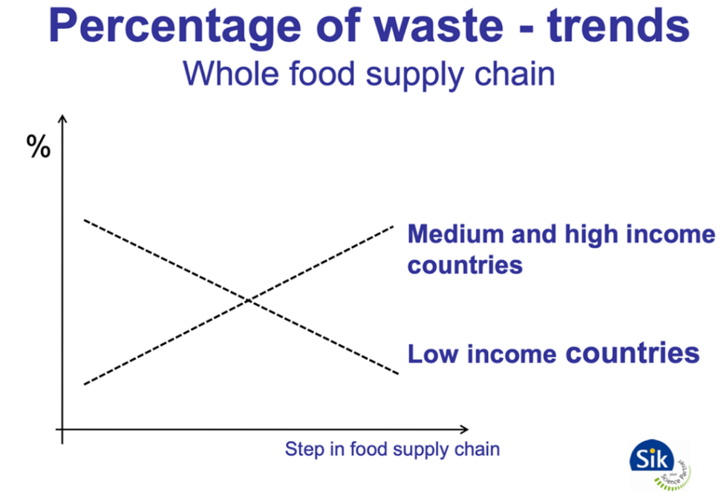

Low-Income Countries | High-Income Countries
CAUSES OF HIGH FOOD LOSSES
WAYS TO PREVENT FOOD LOSSES

