Exercise 6

Study the infographic and then complete the task below.
Use the forum to discuss what those numbers mean for a food business.
- Think of examples in kitchens you have worked in (or in campus kitchens) of when these different kinds of food waste occurred.
- Complete the table and copy it into your journal. Under each of the three headings list as many examples as you can think of.
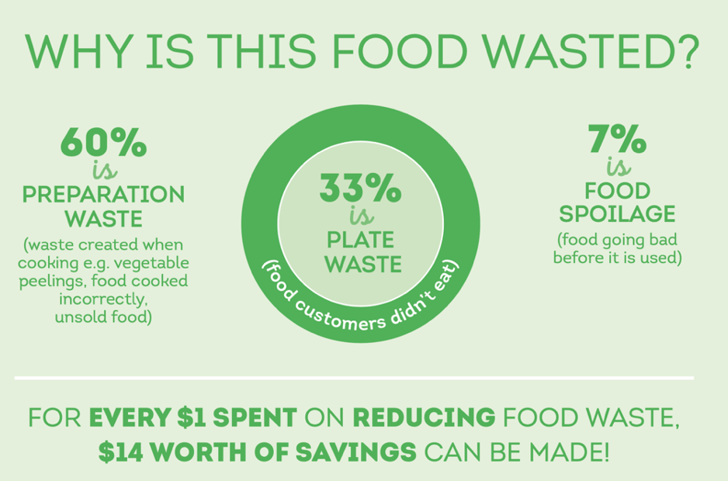

Food Preparation | Plate Waste | Food Spoilage

The following articles about food waste are useful background reading to help with this exercise and also with your assessment.
- Mitigation of Food Wastage - societal costs and benefits
- Champions 12.3 - SDG Target 12.3 on food loss and waste: 2021 Progress Report

