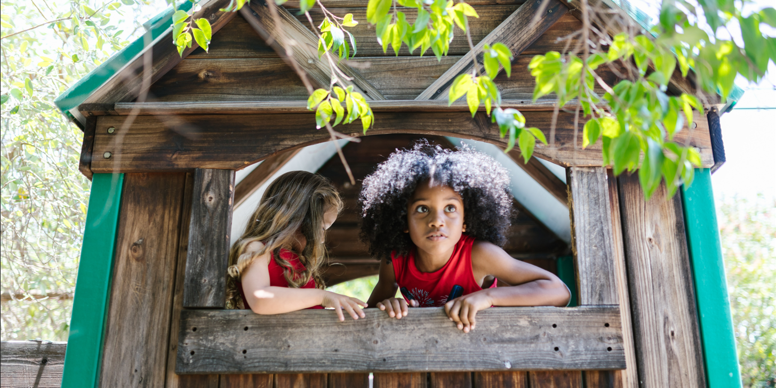

THE GREEN TREEHOUSE INC.

Policy and Procedure Manual

(Extract)

ABN: 46 946 574 148

ACN: 946 574 148

Address: 78 Playground Circle Bendigo VIC 3550

Email: [info@thegreentreehouse.student.com.au](mailto:info@thegreentreehouse.student.com.au)

Phone: 03 4033 7890

1. Company Information

The Green Treehouse is a non-profit early learning centre licensed for 40 children per day. Each of our four rooms has ten children attending per day, grouped according to age. Each room's early childhood education program is delivered by a university-trained early childhood teacher and educators with diploma qualifications. Additional trained staff members support children with disabilities to participate in our early learning program.

We cater for babies, toddlers, and pre-schoolers to provide them with the best caring and educational experience. We offer 3-year-old programs, a fully funded 4-year-old Pre-Prep program and enrichment classes!

The early learning centre is licensed to operate between 7:00 am and 6:30 pm, Monday to Friday. Sessions run for children between 8.00 am and 6:00 pm; Teachers have preparation time in the mornings between 7:00 am, and 8:00 am and in the afternoon from 6:00 pm to 6:30 pm.

**Our Philosophy**

To provide early childhood education that is responsive to current best practices and principles, in partnership with families and the Bendigo community, and contributes significantly to positive outcomes for children.

**Our Management**

The Management Committee is responsible for the efficient administration of the early learning centre, including the setting of fees, the maintenance and improvement of the building, equipment and grounds, the development of policies and staff employment.

**Our Not-for-profit Status**

Being a not-for-profit entity registered under The Australian Charities and Not-for-profits Commission (ACNC), The Green Treehouse can access tax concession. These include:

* endorsed to access income tax exemption (exempt from paying income tax, removing the need to lodge income tax returns)
* endorsed by the ACNC as a deductible gift recipient (DGR) under the school building fund category

GST and Other Tax Liabilities reporting

* GST is reported Quarterly on an accrual basis in the BAS
* PAYGW is reported monthly in the IAS
* Tax Codes used by The Green Treehouse Inc.
  + CAP - Capital Acquisitions
  + GST - Goods & Services Tax
  + FRE - GST Free
  + ITS - Input Taxed Sales
  + INP - Input Taxed
  + N-T - Not Reportable
  + VWH - Voluntary Withholdings
  + ABN - No ABN Withholding

1. **Accounting System**

The Green Treehouse Inc. keeps its accounts on an accrual basis. All source documents must be verified and recorded, adhering to GST principles.

1. **General Ledger**

A chart of accounts has been drawn up in consultation with our accountants, Ace Finance.

Accounts are not to be added to, edited or deleted unless there is no other account that can be used. If accounts are added, care must be taken so that the new accounts are at the correct level so that financial reports print correctly for the management committee.

1. **Recording Sales and Receipts**

The Green Treehouse Inc. recognises, manages and reports income in accordance with tax and privacy legislation and the Australian Accounting Standards. Income is money that the service receives and reports from:

|  |  |  |
| --- | --- | --- |
| Daily Child Care Fees | | |
| Service | Inclusions | Fees (per child) |
| Children under 3 years | Nappies  Wipes  Formula  Food  Milk | $151.00 |
| Children over 3 years | One excursion per quarter  Food  Milk  Kinder Teacher | $137.00 |

The Childcare Subsidy is an Australian Government program that assists families in paying for childcare fees. This financial assistance is paid directly to The Green Treehouse Inc.

If the service receives a Child Care Subsidy (CCS) for a child attending the service, the amount is deducted from the daily childcare fee and parents are invoiced for the fee balance.

* **Fees from parents**

*Child care provided at a recognised facility will be GST-free. Recognised facilities are those that receive government funding or where parents qualify for a Government childcare payment, will be GST-free. Recognised facilities include long day care centres, before and after school care, family day care, occasional care, vacation care and child care facilities at fitness clubs and registered clubs. The Government stated that the basis for the exemption is that child care often includes an educational component.*

* **Subsidies from Government**

*The childcare subsidy is financial assistance to cover the cost of child care.*

*How much families receive depends on several factors, including the family's income, the age of the child, and the paid and unpaid activities, like the job or volunteer work the family is involved in.*

*Extra support is available for some families, such as grandparents and great-grandparents, and families experiencing temporary financial hardship.*

*The CSS is paid directly to providers to reduce the fees families pay.*

[*https://www.ato.gov.au/Business/Business-activity-statements-(BAS)/Goods-and-services-tax-(GST)/Simpler-BAS-GST-bookkeeping-guide/#GSTfreesales*](https://www.ato.gov.au/Business/Business-activity-statements-(BAS)/Goods-and-services-tax-(GST)/Simpler-BAS-GST-bookkeeping-guide/#GSTfreesales)

* **Grants – Early Years Management– Education Victoria**

*The Victorian Government is committed to ensuring all eligible children can access kindergarten programs delivered by qualified early childhood teachers and educators in the year before school and supporting families to understand and engage in children's learning.*

The Green Treehouse receives:

* Annual grant​ of $15,785 (ex GST) – Sessional Kindergarten Services

|  |  |
| --- | --- |
| Kindergarten Services Grant | |
| Date Paid | Amount Received |
| 15 July | $4340.88 |
| 15 October | $4340.88 |
| 15 January | $4340.88 |
| 15 April | $4340.88 |

* Annual grant ​$11,239 (ex GST) – Long Daycare Services

|  |  |
| --- | --- |
| Kindergarten Services Grant | |
| Date Paid | Amount Received |
| 20 July | $3090.73 |
| 20 October | $3090.73 |
| 20 January | $3090.73 |
| 20 April | $3090.73 |

* **Fundraising**

The service holds several fundraising events throughout the year to assist in purchasing additional resources and equipment for the service.

*S. 40-160 of the GST Act provides that all the supplies made by an eligible entity (e.g. an endorsed charity/DGR) in connection with a fundraising event are****input taxed****, provided the charity makes the choice and documents the election with its records.*

* **Donations**

The service often receives donations from families and businesses in the local community towards its building fund. These donations are not reported on the BAS for GST purposes.

* **Interest**

*Interest paid to or received from a bank is not subject to GST.*

[*https://www.ato.gov.au/Business/Business-activity-statements-(BAS)/Goods-and-services-tax-(GST)/Simpler-BAS-GST-bookkeeping-guide/#GSTfreesales*](https://www.ato.gov.au/Business/Business-activity-statements-(BAS)/Goods-and-services-tax-(GST)/Simpler-BAS-GST-bookkeeping-guide/#GSTfreesales)

* **Sale of hats, sheets and T-shirts**

The service purchases hats for outdoor use, bed sheets and T-shirts, which it resells to families. The sale and purchase of these items are taxable sales.

1. **Recording Purchases and Payments**

The Green Treehouse funds are only to be used for business purposes. Purchases and payments must be accurately and completely recorded on a timely basis within the services accounting system.

All purchases under $5,000 must be approved by the service director. Purchases over $5,000, excluding remuneration for staff, must be approved by the management committee.

Purchase must be allocated using the correct GST code.

|  |  |  |
| --- | --- | --- |
| Tax Code | Name | Description |
| GST | Goods & Services Tax | General tax of 10% on most goods, services, and other items sold or consumed in Australia |
| FRE | GST-Free | Sales that are GST-free sales other than export sales, such as fresh food purchases, medical services and products, and educational courses |
| CAP | Capital Purchase | Amounts paid for capital assets, such as plant and equipment, motor vehicles, land and buildings |
| ITS | Input Taxed Sales | Used for the sale of input taxed supplies, or supplies that don't include GST in the sale price, such as financial supplies, interest income and residential income |
| GNR | GST Not Registered | Used to record purchases from suppliers who have an ABN but are not registered to collect GST |
| ABN | No ABN Withholding | Used for suppliers that have not quoted ABNs on their invoices or for amounts that are withheld from investment income because no tax file number was quoted |
| N-T | No-Tax | Used to record sales that carry no GST, such as depreciation and cash transfers. |

The service will withhold 47% of the total payment for a supplier invoice that does not quote an Australian Business Number (ABN).

1. **Electronic Filing**

Copies of all reports printed and documents created are stored electronically in a file named 'The Green Treehouse Inc.'. Documents will be filed using the naming protocol "**FNSTPB401_Student Name_description of the report/document.**"

For example, FNSTPB401_Student Student_The Green Treehouse Inc. policy & procedure manual.

1. **Fixed Assets Register**

Cherrie Harbour, the centre's Director, will be responsible for purchasing assets after approval from the Management Committee.

A file is kept for each asset purchased. This file should include the tax invoice, warranties, loan arrangements, and other documentation regarding the acquisition. When sold, sales documentation should be added to the file.

The organisation is not taking advantage of the small business income tax concessions on depreciation rules.

1. **Errors and Discrepancies**

The accounts must be accurate and correct at all times. Andrew Black, the accountant, reviews any discrepancies identified and provides suggestions on rectifications. Appropriate notes must be kept in the data file against each transaction that will assist with the understanding of the entry should it need to be reviewed. Where necessary, entries should not be deleted or reversed (e.g. dishonoured cheque). The entry in your data file should be adjusted as needed with explanations of changes recorded in the transaction.

If an incorrect tax code has been used in a previous BAS, a journal entry is recorded in the current period to correct the error.

1. **GST and BAS & IAS reporting**

**Lodging BAS**

Ace finance is engaged to provide BAS agents services to The Green Treehouse Inc.

The BAS, IAS and associated documents must be sent to Andrew Black from Ace Finance to check the accuracy of the activity statement.

Andrew must receive the draft activity statement and all associated documentation at least seven (7) days before the due date.

If there are insufficient funds to pay by the due date, the BAS & IAS must be lodged on time to avoid penalties. This will give The Green Treehouse Inc. certainty of their position with the ATO and shows we are aware of our tax obligations.

The due date is usually on the 28th day of the following month. If the due date is on a weekend or public holiday, you can lodge your form and make any payment due on the next business day.

**Adjusting the BAS**

An adjustment relates to a reported sale or purchase that was correct at the time of lodgement, but something occurred later that changed the amount of reported GST.

The Green Treehouse Inc. will make an adjustment for a sale/purchase if all the following apply:

* during a reporting period, an adjustment event occurs for a sale/purchase
* The Green Treehouse Inc. accounted for the sale or purchase in the activity statement for a previous reporting period
* as a result of the adjustment event, the GST amount we previously reported no longer reflects the correct GST amount.

**Working out adjustments for sales**

If The Green Treehouse Inc. have to make an adjustment for a sale they made, the adjustment amount is:

* a decreasing adjustment if The Green Treehouse Inc. originally paid more than the amount payable once the adjustment event is taken into account. In this case, you pay less GST for the reporting period. The Green Treehouse Inc. must reimburse the customer before reporting it on their activity statement
* increasing adjustment if The Green Treehouse Inc. originally paid less than the amount payable once the adjustment event is taken into account. In this case, you pay more GST for the reporting period.

**Working out adjustments for purchases**

If The Green Treehouse Inc. have to make an adjustment for a purchase they made, the adjustment amount is:

* an increasing adjustment if The Green Treehouse Inc. claimed more for the purchase in the earlier tax period than the amount they could have claimed if the adjustment event had been taken into account.
* a decreasing adjustment if The Green Treehouse Inc. claimed less for the purchase in the earlier tax period than the amount they could have claimed if the adjustment event had been taken into account.

[When to make adjustments | Australian Taxation Office (ato.gov.au)](https://www.ato.gov.au/Business/GST/In-detail/Managing-GST-in-your-business/Reporting,-paying-and-activity-statements/Making-adjustments-on-your-activity-statements/?anchor=Adjustmentevent#Adjustmentevent)

**Filing BAS documents**

Copies of the following reports are kept for our records and filed per the electronic filing protocol.

* BAS as lodged
* Lodgement authorisations
* BAS Audit Reports

1. **End of Month Reconciliation**

* **Bank Reconciliation**
* At the end of the month, all bank accounts are reconciled to ensure the Cash at bank accounting records match the records kept by your bank.
* **Accounts Receivable Reconciliation**
* At the end of the month, a receivables reconciliation report is printed and checked for accuracy.
* **Accounts Payable Reconciliation**
* At the end of the month, a payables reconciliation report is printed and checked for accuracy.
* **GST Reconciliation**
* The business accounts for GST on an accrual basis. The bookkeeper must print the following reports when preparing the BAS or IAS:
* GST Summary – Accrual report for the BAS reporting period
* Profit and Loss statement for the BAS or IAS reporting period
* Balance sheet for BAS or IAS reporting period