Instructions to the assessor
The student is required to create an email to the company Chief Financial Officer(CFO) informing them that the procurement management plan and accompanying documents are ready for review and approval. Ensure that the language used is professional and to the point. The student is not required to create a long email with all of the details – the purpose of the assessment is more to ensure that the student can share the relevant condensed information and consult with stakeholders in a professional manner at appropriate points throughout the procurement process.
Ensure that they have explicitly requested approval to proceed. Ensure that the email is addressed correctly and to the right people: Wi Zhang with Henry Thomas and Gavin Stead in cc.
The example given below is to be used as a guide, and it is reasonable that the student will create an email that is different to this. Ensure that the main themes represented in the example are covered.
Email Template

To: | Wi Zhang
From: | Dave O’Connor
CC: | Henry Thomas, Gavin Stead
BCC:
Date/time: | Thursday, 3 p.m.
Subject: | Procurement of office printers
Attachments: | Procurement management plan
To Wi,
As per the instructions I received from Henry regarding the purchase of new office printers, I have created a procurement management plan. This includes the suppliers I have researched and would like to contact to officially request a quote from.
Please review this document, and if you find that it is ready to commence the procurement, please sign off with your approval, and I will begin approaching the short-listed suppliers.
If you have any questions or comments on the plan, please be in touch, and I’ll make the recommended adjustments immediately.
Kind regards,
Dave
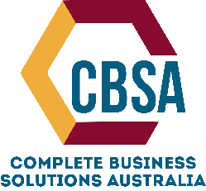
Dave O’Connor, Sustainability Expert
300 Fictional Way, Sydney, NSW 2000
Phone: 1800 111 222
www.cbsa.com.au

