**Module 5 Week Four Exercise 20 and SDL Worksheet**

Exercise 20

1. How do electrical plans and specifications differ?
2. What are some advantages of using electrical plans in the installation process?
3. What are some advantages of using electrical specifications in the installation process?
4. When might it be more appropriate to use an electrical plan rather than an electrical specification?
5. When might it be more appropriate to use an electrical specification rather than an electrical plan?
6. How can using electrical plans and specifications together provide additional benefits in the construction process?

**Self-directed Learning**

Refer to this about the electrical plan to answer the following questions.

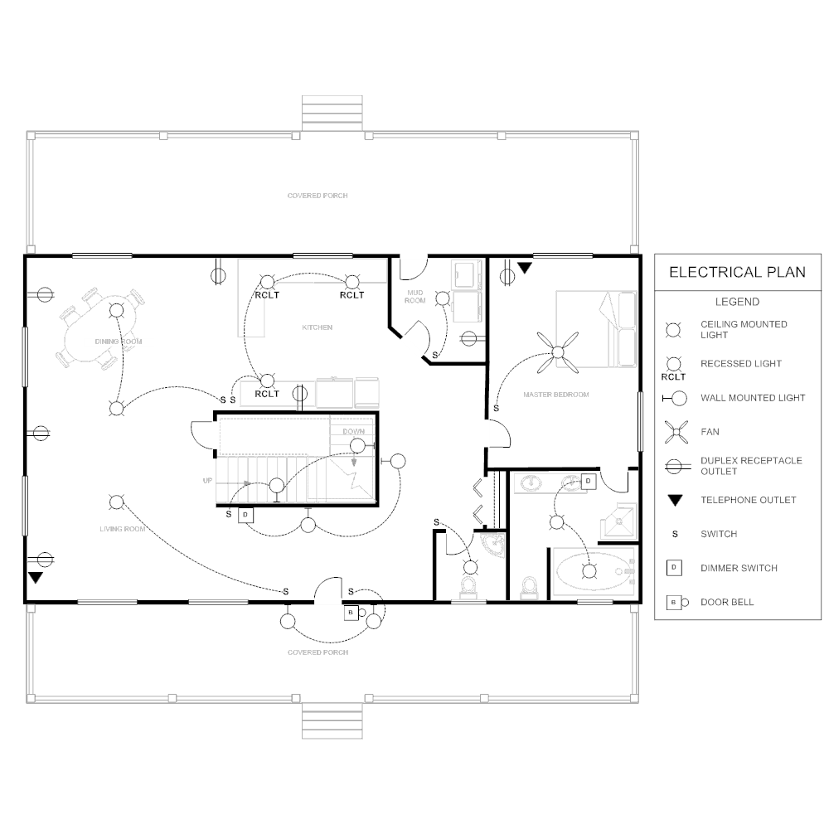

(https://www.smartdraw.com/electrical-plan/examples/electrical-plan/)

1. Create a legend for the plan by drawing the correct symbol for each fitting below.

|  |  |  |
| --- | --- | --- |
|  |  |  |
| ceiling mounted light | recessed light | wall mounted light |
|  |  |  |
| fan | duplex receptacle  (double socket) | telephone outlet |
|  |  |  |
| switch | dimmer switch | doorbell |

1. What do you think the curving dashed lines on the electrical plan represent?
2. How many ceiling lights are there in the bathroom?
3. How many lights does the switch in the kitchen operate?
4. What type of lighting should be installed in the stairwell??
5. Where have dimmer switches been used?