**Module 5 Week Four Exercise 21 22 Worksheet**

**Exercise 21**

Interpret the electrical floor plan for the residential dwelling.

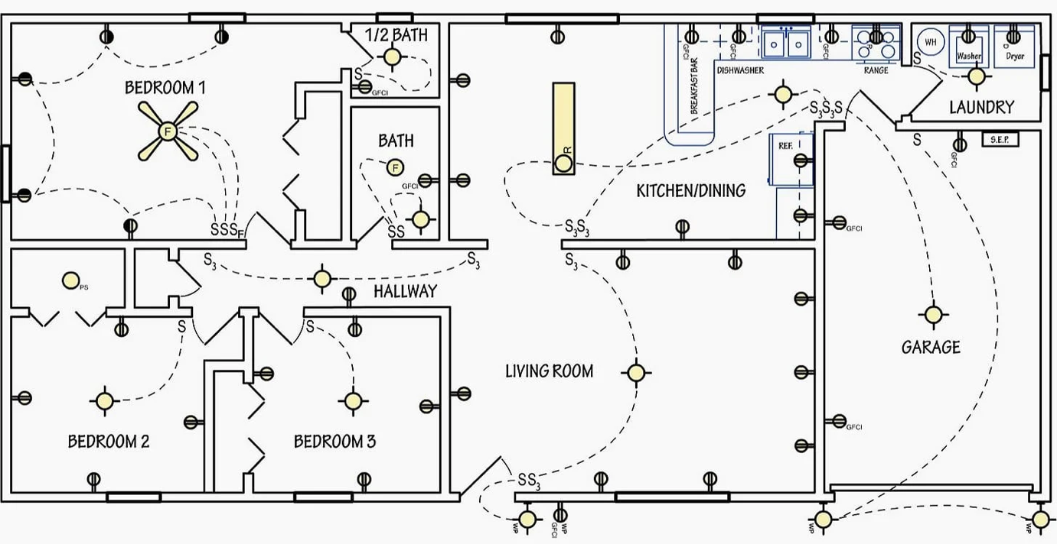

(<https://electrical-engineering-portal.com/download-center/books-and-guides/electrical-engineering/electrical-wiring-home/comment-page-1>)

1. The electrical floor plan does not include a legend. Create a legend suitable for this plan.

2. Prepare a plan specification. Write your answers in the table provided. Post your table on the class forum to check whether you correctly identified all the electrical devices and their quantities.

|  |  |
| --- | --- |
| Part of the House | Electrical Device & Quantity |
| Bedroom 1 |  |
| Bedroom 2 |  |
| Bedroom 3 |  |
| Bathroom |  |
| ½ Bathroom  (en suite) |  |
| Hallway |  |
| Living room |  |
| Kitchen/Dining |  |
| Laundry |  |
| Garage & Outdoor |  |

**Exercise 22**

Answer the following questions regarding electrical plans. Make sure you cite any references you use to find your answers. AS/NZS3000:2018, NZECP 51:2004 etc.

1. What is the minimum height that a switchboard must be installed above a floor according to?
2. What are two places that switchboards are not allowed to be located?

1. What is the minimum number of lighting circuits required for a domestic installation?
2. Name two domestic appliances require their own circuit.
3. What distance must a cable in your electrical installation be placed from a telecommunications circuit, or a circuit operating at a voltage different from 230V?
4. What is the maximum number of 10A double power outlets per circuit allowed in areas other than kitchens and laundries?
5. What is the maximum number of 10A double power outlets per circuit allowed in kitchens and laundries?
6. What is the minimum height a socket-outlet must be installed above the floor of a bathroom or laundry?
7. Which types of fixed electrical equipment in residential installations require RCD protection?
8. What is the maximum rated residual current that RCDs protecting these circuits?