Module 5 Week 1 Exercise 3 and SDL Worksheet

Refer to the diagrams in each case to answer the questions:

- What is a bimetal strip in a miniature circuit breaker, and how does it work?
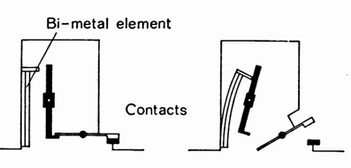

- What is a solenoid in a miniature circuit breaker, and how does it work?
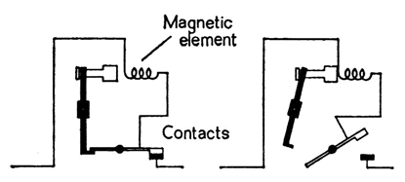

- How do bimetal strips and coils or solenoids differ in their response time to overcurrent conditions?

SELF-DIRECTED LEARNING

Scenario: A homeowner is planning to install a new electrical system in their home and needs to choose between a circuit breaker and a miniature circuit breaker as the protective device for each circuit. As an electrical engineer, you are tasked with advising the homeowner on the best protective device for their electrical system.

Considerations:
- The electrical system will have multiple circuits with different loads and voltages.
- The homeowner wants a protective device that is reliable, efficient, and cost-effective.
- The electrical system will be used for both residential and commercial purposes.

Answer the following questions to assist with your advice the homeowner:
- What are the main differences between circuit breakers and miniature circuit breakers?

- What are the advantages and disadvantages of each type of protective device?

- How do the load and voltage of each circuit impact the choice of protective device?

- What are the safety considerations when choosing a protective device for an electrical system?

SOLUTION/ADVICE

