Module 5 Week Three Exercise 12 and SDL Worksheet

Exercise 12

Test your understanding of scale drawing.
- What does a scale of 1:50 mean in a house floor plan?
- Why are scales used in house floor plans?
- A floor plan has a scale of 1:500. If the distance between two rooms on the floor plan is 6 cm, what is the actual distance between the two rooms?
- A floor plan has a scale of 1:100. The kitchen on the floor plan measures 4m by 3m. What is the actual area of the kitchen in m²?
- A floor plan has a scale of 1:50. The living room on the floor plan measures 6m by 5m. What is the actual perimeter of the living room in metres?
- A floor plan has a scale of 1:100. The distance between two electrical outlets on the floor plan is 3m. What is the actual distance between the two outlets in metres?

- The lines shown in the table represent dimensions from a drawing. For each line, measure the length in millimetres then determine the actual size of the dimensions.
# | Line | Scale
 |  | 1:50 | 1:100 | 1:20
a.
b.
c.
d.

- Determine the scale size of the dimension given in the table for the scale specified.

# | Length Dimension | Scale | Scale Size
a. | 17500 | 1:100
b. | 1860 | 1:20
c. | 14500 | 1:500
d. | 25 | 2:1

SELF-DIRECTED LEARNING

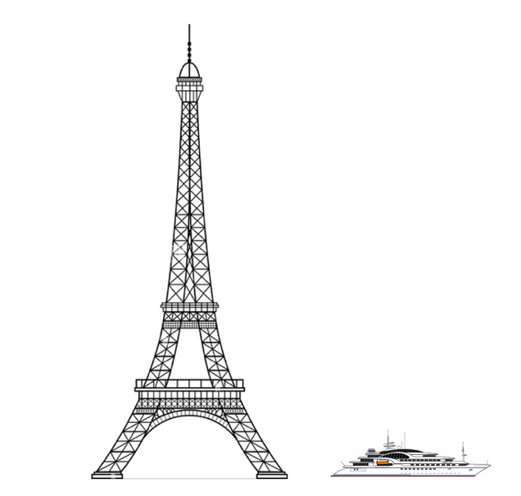
- The diagram shows the Eiffel Tower in Paris. Alongside the tower is a super yacht. Both diagrams are drawn to the same scale and the real length of the yacht is 110 metres.

- Measure the length of the yacht in the diagram in cm and find the scale.

- Use this scale to calculate the actual height of the Eiffel Tower. (Show working.)

- The following drawing shows a scale diagram (floor plan) of a house.

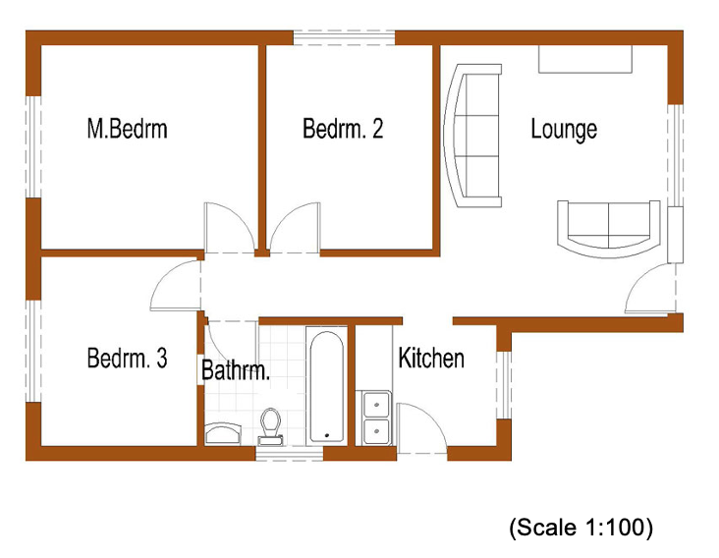
- Use the scale to calculate the floor area of the house in m².

- The owner of the house decides to add a deck adjoining the right wall of the lounge. The deck will be 3m wide. Using the same scale, sketch the new deck on the plans.

