**Marker Guide 10**

**CERTIFICATE IV IN HEALTH ADMINISTRATION**

Manage Business Risk

BSBOPS504



First Edition, March 2023

Copyright ownership: Australian Institute of Professional Counsellors Pty Ltd

ACN 077 738 035

This book is copyright protected under the Berne Convention.

All rights reserved. No reproduction without permission.

Australian Institute of Professional Counsellors

Head Office

47 Baxter St., Fortitude Valley, QLD 4006.

This book is protected by copyright and may not be reproduced or copied either in part or in whole nor used for financial gain without the express approval in writing of the owner (Australian Institute of Professional Counsellors Pty Ltd (ACN 077 738 035) of the copyright.

SHORT RESPONSE QUESTIONS

Section 1

Establishing Risk Context

Understanding business risk

1.1 Through detailed analysis and planning any business would be able to understand and identify any potential risk that may impact their business. Briefly outline two (2) potential impact to a business for each of the following acknowledged risks (Each response should be approximately 30 words).

|  |  |
| --- | --- |
| **Identified risk** | **Potential impact** |
| 1. Coronavirus (COVID-19) | * Customer behaviour changes * Staff unable to work * Cleaning and restocking time and costs |
| 1. Heavy Floods | * Unable to trade * Premises closed * Cost of time for cleaning up and rebuilding * Customers cannot get through * Suppliers cannot get through |
| 1. Disruption to power during specific hours | * Electrical, gas, and water disruption to the business premises * Access to business premises disrupted including parking, deliveries, and pedestrian traffic |

Introduction to risk management

1.2 Briefly explain the importance of Risk Management and identify its five (5) key stages. (Your response should be approximately 40 words).

|  |
| --- |
| Student’s response must demonstrate an understanding of ISO risk management processes involved and be able to explain the purpose/importance of risk management.  Responses must include the following; however exact wording might vary:  “Risk management on the other hand, enables organisations to achieve their objectives through assertive decision making based on information derived from existing data analysis.” The key stages of risk management are as follows:  1. Establishing the context  2. Risk identification  3. Risk analysis  4. Risk evaluation  5. Risk treatment |

1.3 The AS/NZS ISO 31000:2018 Risk Management – Guidelines details critical Australian standards on risk management processes and eleven key principles of risk management. Briefly outline these eleven (11) keys principles in your own words. (Your response should be no more than 300 words)

|  |
| --- |
| Student’s response must demonstrate an accurate understanding of the key principles of risk management.  Responses may include, but are not limited to, reference to:   * **Creates value -** Good risk management contributes to the achievement of an agency’s objectives through the continuous review of its processes and systems. * **Integral part of organisational processes -** Risk management needs to be integrated with an agency’s governance framework and become a part of its planning processes, at both the operational and strategic level. * **Part of decision making** - The process of risk management assists decision makers to make informed choices, identify priorities and select the most appropriate action. * **Explicitly addresses uncertainty** - by identifying potential risks, agencies can implement controls and treatments to maximise the chance of gain while minimising the chance of loss * **Systematic, structured and timely** - the process of risk management should be consistent across an agency to ensure efficiency, consistency and the reliability of results. * **Based on the best available information** - To effectively manage risk it is important to understand and consider all available information relevant to an activity and to be aware that there may be limitation on that information. It is then important to understand how all this information informs the risk management process. * **Tailored** - An agency’s risk management framework needs to include its risk profile, as well as take into consideration its internal and external operating environment. * **Takes human and cultural factors into account** - Risk management needs to recognise the contribution that people and culture have on achieving an agency’s objectives. * **Transparent and inclusive** - Engaging stakeholders, both internal and external, throughout the risk management process recognises that communication and consultation is key to identifying, analysing and monitoring risk. * **Dynamic, iterative and responsive to change -** The process of managing risk needs to be flexible. The challenging environment we operate in requires agencies to consider the context for managing risk as well as continuing to identify new risks that emerge and make allowances for those risks that no longer exist. * **Facilitates continual improvement and enhancement of the organisation** - Agencies with a mature risk management culture are those that have invested resources over time and are able to demonstrate the continual achievement of their objectives |

1.4 Every organisation usually has specific existing arrangements when it comes to risk management.

a) Briefly identify four (4) responsibilities of every staff member in contributing to an enterprise-wide risk management process. (Your response should be approximately 100 words)

|  |
| --- |
| Student’s response must be able to identify the responsibilities of staff using the risk management policy extract from Department of Planning and Environment.  Responses must include the following; however exact wording might vary:   * Understanding that risk management is a hands-on process. It is the recognition of risks, and the coordinated and economical application of resources to reduce the likelihood of them occurring or minimising their impact; * Identifying, reporting and/or managing risks in a timely manner; * Encouraging and supporting other staff in identifying, reporting and managing risks; and * Complying with the department’s policies and procedures designed to address particular types of risk. |

b) List (4) documents or existing organisational arrangements that should generally be reviewed to help establish the risk context. (Your response should be approximately 20 words).

|  |
| --- |
| Student’s response must identify four documents or existing organisational arrangements that should be reviewed when undertaking risk management.  Responses must include the following; however exact wording might vary:   * Organisational strategy * Goals and objectives * Operational plans * Projects * Organisational policies and procedures * Organisational structure * Accountability arrangements |

1.5 When risks have been identified the situation requires the participation and support from key stakeholders and higher management. Briefly identify five (5) ways in which these risks can be communicated to the stakeholders in order to gain their support. (Your response should be approximately 80 words).

|  |
| --- |
| Student’s response must demonstrate an accurate understanding of guidelines for communicating with stakeholders to gain support and invite participation.  Responses may include, but are not limited to, reference to:   * Know the stakeholders, by identifying both external and internal stakeholders and finding out their interests and concerns * Simplify the language and presentation, although not the content if complex issues need to be communicated * Be objective in the information provided and differentiate between opinions and facts * Communicate clearly and honestly, taking account of the level of understanding of the audience |

1.6 Briefly describe the five (5) contexts that make up the external environment and how they can influence risk management activities. (Your response should be no more than 50 words)

|  |
| --- |
| Student’s response must demonstrate an accurate understanding of the external context of risk management.  Responses may include, but are not limited to, reference to:   * **The political context** refers to the risks which could arise due to changes in policy or government. Political factors that may influence risk management activities include taxation, government funding, infrastructure or trade policy. * **The economic context** refers to the risks which could arise due to change s to the global economy or the local market. Economic conditions which could impact on risk management activities include economic growth and decline, consumer spending, interest rates, inflation and unemployment. * **The social context** refers to the risk which could arise due to societal changes. The social context includes demographics, population growth, an aging population and social trends such as health consciousness. * **The technological context** refers to the risks which could arise due to technological advancements. Technological factors which could influence risk management activities may include automation, research and development and technological obsolescence. * **The legal context** refers to the risks which could arise due to legislation or changes to legislation. Legislation which may impact on risk management may include: the Model Work Health and Safety Act, the Corporations Act, contract law, the Environmental Protection and Biodiversity Conservation Act, the Freedom of Information Act, the Fair Work Act and the Privacy Act. |

Integrating your knowledge

To respond to the questions in this section of the Assessment Book you are to imagine that you are the Operations Manager for Tranquillity Wellness Centre, a holistic health and wellness centre located in the inner suburbs of Brisbane. The CEO of Tranquillity Wellness Centre has asked you to develop a risk management plan for your department. As Operations Manager you are responsible for a team of five wellness practitioners who specialise in chiropractic, acupuncture, naturopathy, homeopathy and massage therapy and two customer service officers who are responsible for managing customer bookings as well as various other administrative duties.

Extracts from key Tranquillity business documents are included at the end of this Assessment Book under ‘Assessment Supporting Documents’. You will need to review these documents in order to respond to some of the questions below.

1.7 Review Tranquillity’s existing arrangements for risk management (see Supporting Documents A and B which can be found at the end of this Assessment Book).

a) Briefly describe the strengths and weaknesses of Tranquillity’s existing arrangements based on the core principles of risk management described in AS/NZS ISO 13000:2018. (Your response should be no more than 200 words)

|  |
| --- |
| Student’s response must demonstrate an understanding of the strengths and weaknesses of existing arrangements based on the core principles of risk management.  Responses may include, but are not limited to, reference to:   * Risk management policies do not create value for the organisation * Risk management principles are not integrated into organisational strategy * Risk management principles are not an integral part of strategic planning * Risk management policies and procedures are systematic and structured * Risk management policies appear to be based on best information * Risk management policies are tailored to the organisation * Existing arrangements do not take into consideration cultural factors * Strategy, policies and procedures appear to be transparent and inclusive * Risk management policies are designed to comply with legislation rather than being dynamic, iterative and responsive to change * Policy and strategy fail to facilitate continuous improvement |

b) Consider the background information you have been provided with at the start of this section as well as Tranquillity’s organisational structure (see Supporting Document C which can be found at the end of this Assessment Book). Briefly outline the scope of the risk management activities you must complete. (Your response should be no more than 50 words)

|  |
| --- |
| Student’s response must have an understanding of specific risk management activities.  Responses may include, but are not limited to, reference to:   * The operations department * The wellness practitioners * Customer service officers |

c) Consider the information provided in Tranquillity’s Strategic Plan (Supporting Document A which can be found at the end of this Assessment Book) and identify one goal that is relevant to the scope of your department. In the appropriate space below, document this goal and three critical success factors for achieving this goal. (Your total response should be no more than 50 words)

|  |  |
| --- | --- |
| Responses will vary but should demonstrate an understanding of Tranquility’s goals the critical success factors required to achieve those goals, for example. | |
| **Goal** | **Critical Success Factors** |
| Introduce meditation classes to Tranquility’s range of services by in the next 12 months. | Appropriate meditation area |
| Trained meditation instructors |
| Marketing/advertising |

1.8 Read the case scenario and answer the following questions.

Jane and her colleague, Mike, have decided to set up an allied health centre together in Victoria. Jane will be the practice manager and Mike will provide physiotherapy services. They are looking to recruit other allied health professionals, however in the meantime they will start up their business by marketing physiotherapy.

a) Jane and Mike will be equally responsible for the management of this business, and each of them will have unlimited liability for any risks that occur at the business. Using the arrangements provided in your Study Guide, identify the four (4) specific arrangements that Jane and Mike would have to consider when they undertake risk management. (Your response should be approximately 30 words).

|  |
| --- |
| Student’s response must demonstrate an understanding of existing arrangements to manage and control risks to the business.  Responses may include, but are not limited to, reference to:   * Organisational strategy * Goals and objectives * Operational plans * Projects * Organisational policies and procedures * Organisational structure * Accountability arrangements |

b) After one month of being open, Jane and Mike are looking at obtaining more funding for the practice so that they can extend their services to the community. They have made an appointment with a finance banking officer and would like to discuss their options. The Banker had mentioned that its best they come prepared with any profits and loss or even troubles they may have faced in this month.

Outline four (4) guidelines that Jane and Mike must understand and follow as small business owners in order to communicate to their banker about any risk management activities at the business. (Your response should be approximately 50 words).

|  |
| --- |
| Student’s response must demonstrate an understanding of communicating any risk management activity to stakeholders in order to receive their support.  Responses may include, but are not limited to, reference to:   * Know the stakeholders, by identifying both external and internal stakeholders and finding out their interests and concerns * Simplify the language and presentation, although not the content if complex issues need to be communicated * Be objective in the information provided and differentiate between opinions and facts * Communicate clearly and honestly, taking account of the level of understanding of the audience |

c) Jane and Mike have now received approval for some funding, and they have just recruited a lot of other allied health professionals. They need to make their stakeholders (patients, workers and any higher management involved) aware of risk management, so it is identified and controlled at first glance. Briefly outline a risk management policy that Jane and Mike can implement for their staff to adhere to. (Your response should be approximately 200 words)

|  |
| --- |
| Student’s response must demonstrate an understanding of having a risk management policy and what needs to be included in it so that their staff are able to identify and manage any risks that they may come across.  Responses may include, but are not limited to, reference to:  This policy applies across all departmental operations and to all departmental staff, consultants and contractors. It also applies to the operations and staff, consultants and contractors of all department Cluster entities who have staff employed in or through the department Risk is the effect of uncertainty on our objectives. The Department of Planning and Environment (department) aims to create a positive organisational culture that promotes risk management as part of effective corporate governance which supports informed and well-judged decision making. Every function has a degree of risk, and the department recognises that identifying risks and managing them is critical to the achievement of our goals.  All department staff are responsible for contributing to an enterprise-wide risk management process by:   * Understanding that risk management is a hands-on process. It is the recognition of risks, and the coordinated and economical application of resources to reduce the likelihood of them occurring or minimising their impact; * Identifying, reporting and/or managing risks in a timely manner; * Encouraging and supporting other staff in identifying, reporting and managing risks; and * Complying with the department’s policies and procedures designed to address particular types of risk.   This policy outlines the department’s approach to risk management and prescribes a minimum set of risk management standards for all business areas across the department Cluster. |

d) Now that Jane and Mike have put in place risk management policies and the business is running smoothly, however they have been facing a few risks surrounding an environmental context. Read through the following issues and identify which environmental context they should consider to avoid these risks from happening again. (Your response should be approximately 1 word).

i) The staff have been complaining about not receiving their contracts and agreements on time. Sometimes when they do request for a pay slip, and it takes around two weeks for the request to be approved.

|  |
| --- |
| Student’s response must identify the correct environmental context that can affect Jane and Mike’s business.  Legal context – The Fair Work Act 2009 |

ii) A new government has taken over control the same year of Jane and Mike opening their new business, and have implemented an increase in business tax by 10%.

|  |
| --- |
| Student’s response must identify the correct environmental context that can affect Jane and Mike’s business.  Political context |

iii) The system to enter all patients details have been really slow and time consuming. Patients have been kept waiting for over 10 to 15 minutes just to get their details added on the system and this had led to less patients checking-in to the facility as they are always left frustrated with the wait-time.

|  |
| --- |
| Student’s response must identify the correct environmental context that can affect Jane and Mike’s business.  Technical context |

e) Jane and Mike were provided the following statements/questions by their stakeholders to analyse the strengths and weaknesses of the business’ current risk management process. Identify which criteria the stakeholders were looking to assess based on the following information. Hint: see **extract** (AS/NZS ISO 13000:2018) under the heading **Review existing arrangements** in the Study Guide. (Your response should be approximately 30 words each).

|  |  |
| --- | --- |
| Student’s response is expected to indicate that they would review the current processes against the AS/NSZ ISO 31000:2018 Risk Management –Guidelines, however other responses are acceptable as long as the student outlines useful criteria to analyse strengths and weaknesses of current processes.  Responses may include, but are not limited to, reference to the AS/MZS ISO 31000:2018 core principles of: | |
| **Statement/questions from the stakeholders** | **Criteria** |
| i) Have you considered internal and external operating environment? Can you provide us with examples? | Tailored |
| ii) You must try and consider, recognise and value the contribution of the present employees in achieving the business’s objectives. | Takes human and cultural factors into account |
| iii) Try to make informed choices, identify priorities and select the most appropriate action. | Part of decision making |

Section 2

Identifying Risks

Types of Risk

2.1 There are many types of risks that businesses need to be aware of.

a) Briefly identify and explain four (4) types of risks to a business. (Your response should be approximately 150 words)

|  |
| --- |
| Student’s response must demonstrate an understanding of various types of risks that can affect a business.  Responses may include, but are not limited to, reference to:   * Premises - there are a range of risks associated with the premises where work is performed. Premises may pose risks in the form of unsuitable or unsafe premises, ownership or leasing requirements, repairs, location, environment, security, and competition. * Product or Service - risks associated with products or service may include demand for the product or service, availability of suitable workforce, employment law, product safety, consumer protections, licensing, copyrights or patents, competition, demographics, storage, and delivery. * Purchasing - purchasing refers to the risks associated with the purchasing or procurement function of the organisation. These risks may relate to the organisation’s policies and procedures, cost of supplies, fuel and transportation costs, technology and obsolescence, environmental issues, and reputation |

b) It is important to research risks that apply to the specific scope of the risk management process being developed.

i) Briefly describe the difference between primary research and secondary research. (Your response should be no more than 50 words).

|  |
| --- |
| Student’s response must demonstrate an understanding of the key differences between primary and secondary research.  Responses may include, but are not limited to, reference to:   * Primary research or original research is research that hasn’t already been conducted by somebody else. It is “collected specifically for the purpose of the research project being undertaken”. Unlike primary research, secondary research is based on research which has already been conducted, analysed and written about by somebody else. |

ii) Identify four (4) sources of research (primary or secondary) that can assist in identifying risks. (Your response should be no more than 40 words).

|  |
| --- |
| Student’s response must demonstrate an understanding method of identifying risks.  Responses may include, but are not limited to, reference to:   * Observation of behaviour, processes or events. * Interviews with key stakeholders. * Surveys or questionnaires of key stakeholders. * Sales records, financial statements, incidents reports and other records. * Books * Journal articles * Newspapers and magazines * Industry or government reports * Online resources |

Integrating your knowledge

2.2 Let’s go back to being an Operations Manager for Tranquillity Wellness Centre, a holistic health and wellness centre located in the inner suburbs of Brisbane.

a) Review the industry research conducted into work related injuries presented in Supporting Document D which can be found at the end of this Assessment Book. What are three (3) potential risks identified in this research that apply to Tranquillity? (Your response should be no more than 50 words).

|  |
| --- |
| Student’s response must demonstrate an understanding of any potential risks.  Responses may include, but are not limited to, reference to the following:   * Sprain/strain * Hitting or being hit or cut by an object * Exposure to mental stress * Repetitive movement * Falls |

(b) You decide to conduct a risk identification session during the wellness practitioner’s weekly team meeting in order to help further your understanding of the potential for workplace injury at Tranquillity and help ensure that the wellness practitioners participate in the risk management process. List two (2) open questions and two (2) closed questions that you will ask at this meeting. (Your response should be no more than 80 words)

|  |
| --- |
| Students responses will vary but should demonstrate an understanding that the session is being run to further the understanding of potential risks beyond what is included in industry research.  Responses may include, but are not limited to, reference to the following:   * Since working at Tranquility what potential risks have you noticed that could lead to a workplace injury? * Can you explain how working at Tranquility might lead to a staff member experiencing mental stress? * Does Tranquility conduct risk management effectively or not? * Have you ever been injured while working at Tranquility and not reported the injury? |

c) Using the scenario analysis technique, describe the impact one major internal or external event would have on Tranquillity. The event could be a natural disaster an economic downturn, a political shift, war breaking out, technology failure, fraud, theft or any major event you choose. You must develop and outline: i) the best-case scenario

ii) the worst-case scenario and

iii) the most likely scenario.

You must be sure to identify the risks which would be likely to occur in each of your scenarios. (Your response should be no more than 250 words)

|  |
| --- |
| Student’s response must demonstrate an understanding the scenario analysis technique be describing a best case, worst case and most likely scenario.  Responses may include, but are not limited to, reference to the following:  i) Brisbane has been experience heavy and prolonged rainfall and thunderstorms and the area surrounding Tranquillity is expected to flood. The water never reaches the building, Tranquillity receives no damage and power outages only last a short time causing no significant problems. A small number of customers cancel appointments over the next few days due to the storm.  ii) Brisbane has been experience heavy and prolonged rainfall and thunderstorms and the area surrounding Tranquillity is expected to flood. The water rises quickly, enters the property and most of the furniture and electrical equipment is damaged. Strong winds case a tree to fall damaging the roof and other parts of the building. Tranquillity has to shut down for several months to repair the damage. New computers, furniture and equipment must be purchased.  iii) Brisbane has been experiencing heavy and prolonged rainfall and thunderstorms and the area surrounding Tranquility is expected to flood. Several key staff members volunteer to sandbag the front of the property. Luckily no water enters the building. Power goes out for 12 hours. A tree fall into Tranquility’s car park and it is two days before the council can remove it. Tranquility has to close down for 3 days, and all appointments must be cancelled/rescheduled. |

2.3 You have been working as a patient care coordinator for over five years at the same clinic since its opening. Recently, you have noticed that the retention of customers are not that great, and the team has also been looking demotivated. You conducted a survey amongst the staff and some surveys were sent out to the current patients as well. The following table depicts the results/feedback from the survey sent out a month ago.

As a patient care coordinator, identify the risk involved and explain what can be done to minimise it. (Your response should be approximately 30 words each).

|  |  |  |
| --- | --- | --- |
| Student’s response must demonstrate an understanding of identifying the risk in order to provide the necessary examples on how to overcome it.  Responses may include, but are not limited to, reference to the following: | | |
| **Results/feedback from the survey** | **Types of Risk** | **Example on how to overcome identified risk** |
| a) A staff member had mentioned that they have no access to relevant patient data and were unaware of any other competitors in the area | Planning | Maybe have an employee manual on where they can access this type of information. This can be shared via an online system. |
| b) A stakeholder had mentioned that a patient had personally emailed them complaining about the environment of the clinic. It seems there has been no effort taken in frequent cleaning of touch points in the clinic. The patient has also mentioned that they would not be returning due to its uncleanliness. | Premises | We can maybe have a cleaning schedule amongst the staff so that there is frequent cleaning taking place. Just so everyone is aware of their duties and to make sure all touch points are cleaned thoroughly. |
| c) Staff mentioned that there has never been any training or meetings at the workplace. Some of them even mentioned that they pay for their own continuous professional development. | Performance | The manager can try to have weekly meetings to understand how the staff are doing, their well-being and about their workspace. They can also speak to stakeholders to get more funds to provide some inhouse training for the staff this can be on cleaning, hygiene procedures, correct use of equipment or even patient service skills. |

Section 3

Analysing Risks

Assessing likelihood of risks

3.1 Once risks have been identified, it is important to analyse the risk by assessing the likelihood of the risk occurring.

a) List four (4) methods that can be used to assess the likelihood of a risk occurring. (Your response should be approximately 20 words)

|  |
| --- |
| Student’s response must demonstrate an understanding of how to assess the likelihood of a risk-taking place.  Responses may include, but are not limited to, reference to the following:   * History * Forecasting * Mathematical modelling * Expert option * Gut instinct |

b) Identify and define four (4) common terms used to describe the likelihood of a risk occurring. (Your response should be no more than 150 words)

|  |
| --- |
| Student’s response must demonstrate an understanding of the likelihood of a risk-taking place.  Responses may include, but are not limited to, reference to the following:   * Unlikely - can reasonably be expected to occur, but has only occurred 2 or 3 times over 10 years in this organization or similar organizations * Possible - has occurred in this organization more than 3 times in the past 10 years or occurs regularly in similar organizations, or is considered to have a reasonable likelihood of occurring in the next few years * Likely - occurred more than 7 times over 10 years in this organization or in other similar organizations, or circumstances are such that it is likely to happen in the next few years * Almost certain - has occurred 9 or 10 times in the past 10 years in this organization, or circumstances have arisen that will almost certainly cause it to happen |

3.2 It is also vital to assess the impact or consequence if the risk was to occur.

a) List four (4) questions that a risk professional should consider when attempting to determine the impact or consequences of a risk occurring. (Your response should be no more than 50 words)

|  |
| --- |
| Student’s must be able to demonstrate an understanding of what needs to be considered when it comes to determining the impact or consequence of a risk-taking place.  Responses may include, but are not limited to, reference to the following:   * What will happen if the risk occurs? * How severe are the consequences of the risk occurring? * Who will be affected by the risk occurring? * How many people will be affected? * How large an area will be affected? * Will it be possible to repair the damage? * How long will it take to repair? * How much will it cost to repair? * Who will have to pay for the repairs? |

b) Identify and define four(4) terms commonly used to describe risk impact. (Your response should be no more than 150 words)

|  |
| --- |
| Student’s response must demonstrate an understanding on the generic definitions for some commonly used risk impact.  Responses may include, but are not limited to, reference to the following:   * Small - no impact on patient health; minor reduction of reputation in the short run; no violation of law; negligible economic loss which can be restored. * Moderate - minor temporary impact on patient health; small reduction of reputation that may influence trust for a short time; violation of law that results in a warning; small economic loss that can be restored. * Severe - serious impact on health; serious loss of reputation that will influence trust and respect for a long time; violation of law that results; large economic loss that cannot be restored. * Catastrophic - death or permanent reduction of health of patient; serious loss of reputation that is devastating for trust; serious violation of law; considerable economic loss that cannot be restored. |

Integrating your knowledge

3.3 Select four risks that you have previously identified in your response to Question 2.3(a). Assess the likelihood and impact of each of these risks occurring and determine the relative priority of the risks based on their likelihood and impact using the matrix in Section 3 of the Study Guide, under the heading **Evaluate and prioritise risks**. Document your analysis by completing the table below.

|  |  |  |  |
| --- | --- | --- | --- |
| Responses will vary but should demonstrate an understanding of risk likelihood, risk impact and risk priority, for example. | | | |
| **Risk** | **Likelihood** | **Impact** | **Priority** |
| Flood | Unlikely | Severe | Low |
| Power outage | Likely | Moderate | Medium |
| Sprain/strain | Likely | Moderate | Medium |
| Broken Bones | Possible | Severe | High |
| Falls | Likely | Severe | High |

3.4 Read the case scenario below about Lily and answer the following questions.

Lily is the owner of an allied health centre offering a range of services to patients of all ages. She has been running this business for the past three years. Recently, she has been thinking of expanding her practice as well as hiring new employees in order to add more services, including a wellness coach and one administrative staff. Despite already running her allied health practice for three years, Lily recognises that there may be more risks associated with her business expansion and hiring new staff members.

a) Outline two (2) questions that Lily can ask herself to assess her allied health practice and to help identify potential risks. Hint: You may find it helpful to refer to Section 2 and 3 of the Study Guide to answer this question. (Your response should be no more than 25 words)

|  |
| --- |
| Student’s responses will vary but should demonstrate an understanding of how to assess the likelihood of risks.  Responses may include, but are not limited to, reference to the following:   * What if there is no access to internet? * What if key documents were destroyed? * What is the business premise is affected by natural disaster? * What are the risks associated with each stage of my work procedure? * What is my business premise losing electricity supply? * What can I do if several risks occur simultaneously? |

b) Four months later, Lily has decided to move her allied health practice from her home office to a stand-alone facility in the heart of the city. The practice will be surrounded with serenity and close to all public transportation which means patients have easy access to the facility. However, she just found out that the area is now prone to flash flooding, which has occurred around twice over the past ten years. In addition, Lily needs to consider the workplace layout for two other allied health professionals as a well as a reception area for her administrator.

Identify one (1) unlikely-based risk and one (1) almost-certain risk. (Your response should be approximately 15 words).

|  |
| --- |
| Student’s responses will vary but should demonstrate an understanding of how to identify the potential business risks.  Responses may include, but are not limited to, reference to the following:   * Unlikely-based risk: damage by flash flood/natural disaster * Almost-certain risk: ergonomic hazards such as poor workplace layout/low employee morale |

c) Assess the probability that a flash flood is going to occur to Lily’s new allied health practice premises. Hint: refer to the risk likelihood from Hopkin (2017) under the heading **Evaluate and prioritise risks** in Section 3 of the Study Guide. (Your response should be 1 word)

|  |
| --- |
| Responses must be correct.  Moderate |

d) After looking at the probability of flash flooding, Lily wants to assess the impact of this risk to help develop her risk management plan. Outline four (4) questions that Lily can ask herself to do so. (Your response should be approximately 30n words)

|  |
| --- |
| Student’s response must demonstrate an understanding of how to assess impact of risk to help develop a risk management plan.  Responses may include, but are not limited to, reference to the following:   * What will happen if the flash floods occur? * How severe are the consequences of the flash flood occurring? * Who will affected by the flash flooding occurring? * How many people will be affected by the flash flood? * How large an area will be affected by the flash flood? * Will it be possible to repair the damage? * How long will it take to repair? * How much will it cost to repair? |

e) After Lily assesses the identified risks, she realises she would not have the time to manage and treat all these risks before commencing operations at the new business premise. Hence, she would need to come up with a plan to prioritise these risks to determine which risk to treat first.

Briefly outline one (1) method that Lily could adopt to evaluate and prioritise the identified risks. (Your response should be approximately 40 words)

|  |
| --- |
| Student’s response must demonstrate an understanding of how to develop a plan to evaluate and prioritise risks to treat first.  Responses may include, but are not limited to, reference to the following:   * Using the formula, “level of risk = consequence x likelihood” to calculate each risk’s level of risk and compared it against a table of risk rating. Then, determine the action that needs to be taken now. * Draw a risk matrix, with four quadrants looking at low and high levels of impact and likelihood, respectively. Then, write down each identified risk on the corresponding quadrant and take any necessary actions accordingly. * Other appropriate response may also be accepted. |

Section 4

Selecting and Implementing treatments

Options for treating risks

4.1 Briefly describe the four types of risk responses proposed by Hopkin (2014) and identify when each type of response is most appropriate. Hint: see Section 4 of the Study Guide, under the heading **Select Options for treating risk**. (Your response should approximately 250 words)

|  |
| --- |
| Student’s response must demonstrate an understanding of using the 4T risk response derived from Hopkin (2017).  Responses may include, but are not limited to, reference to the following:   * Tolerating - when a risk is unlikely and has a small impact, it is known as a low priority risk. In most cases the organisation will decide to tolerate low priority risks. Other circumstances where an organisation may tolerate risk are when risks may lead to profit or when the process is essential to the organisation. * Treating - when a risk is likely or almost certain and has a small to moderate impact it is considered a medium priority risk. Most organisations choose to treat these kinds of risks. Seatbelts, airbags, smoke alarms and security systems are all examples of risk treatments. * Transferring - when a risk is unlikely but has a severe or catastrophic impact that risk is considered a medium priority. It is common for organisation to transfer medium priority risk such has these. Risk transfer is sometimes also known as risk sharing to highlight the fact that no risk can be entirely transferred to another party. Methods of transferring risk may include insurance, contractual agreement, partnership or joint venture. * Terminating - when a risk is both likely to occur and will have a severe or catastrophic impact it is considered a very high priority risk. Usually, an organisation will try to terminate high priority risks by “stopping the process or activity, substituting an alternative activity or outsourcing the activity that is associated with the risk”. It sometimes happens that the high risks are associated with a fundamental process or procedure, in which case the organisation usually adopts a combination of the risk treatment and risk transfer approach |

4.2 Briefly describe the four (4) general types of risk controls. (Your response should be approximately 200 words)

|  |
| --- |
| Student’s response must demonstrate an understanding of the types of ways to control risks.   * Preventative controls as the name suggests are designed to prevent, eliminate, substitute or remove the risk before it occurs. Preventative controls may include guard rails, physical barriers, lifting equipment or harnesses. They may also include passwords, separation of duties and adequate training. Preventative controls can also involve substituting a risk with a lesser risk for example using safer cleaning products. * Corrective controls align with the treatment risk response as both approaches seek to reduce the impact if and when a risk occurs. Helmets, airbags, seatbelts, smoke alarms, sprinklers and security alarms are all examples of corrective controls because they seek to reduce the impact of risk controls the risk after it has occurred. Many corrective controls are legally required. * Directive controls involve directing people to act in a particular way. Directive controls may include information, policies and procedures. Instructing employees to wear personal protective equipment, training, communication, incentives, emergency procedures and other policies and procedures are all examples of directive control. Directive controls are considered one of the weakest control measures however they usually form part of a combined approach with the other forms of control. * Detective controls can only be used after a risk has occurred. The purpose of detective controls is to identify the number of times a risk has occurred. These measures can then be used to identify and prevent risks in the future. Detective controls may include; stock take, bank reconciliation, medical records, complaints or incident reports. |

4.3 Risk transfer in the form of insurance is a risk management strategy. Briefly describe the three main categories of business insurance. (Your response should be approximately 100 words)

|  |
| --- |
| Student’s response must demonstrate an understanding of the several types of insurance which businesses should consider.  Responses may include, but are not limited to, reference to the following:   * Mandatory Insurance. Mandatory, compulsory or legally required insurance is designed to compensate third parties for damage caused by the organisation. Mandatory insurance includes; employer liability (also known as workers compensation), public liability, product liability and professional indemnity * Balance Sheet Protection. Balance sheet or profit and loss protection is designed to compensate the organisation for lost profits caused by adverse events. Balance sheet protection may include; business premises, business interruption, asset protection, motor vehicle, terrorism and personnel insurance * Employee Benefit. Employee benefit or protection of employee assets includes life insurance, health insurance and directors/officers liability. Benefits may include; “life cover, critical illness cover, income protection, private medical costs, permanent health cover, personal accident and travel injury/losses” as well as legal and compensation costs to directors or officers. |

Integrating your knowledge

4.4 Select one of the risks you analysed in Question 2.3. Use the matrix with the table headings ‘**Risk Rating’, ‘Description’,** and ‘**Action** in Section 4, under the heading **Evaluate and Prioritise Risks** in the Study Guide to select an appropriate type of risk response based upon the likelihood and impact of the risk. Complete the table below. Note: when selecting appropriate control techniques you should consider the priority of the risk, the risk response, the importance of the process, costs and benefits of the control, and any legal requirements.

|  |  |  |  |
| --- | --- | --- | --- |
| Responses will vary but should demonstrate an understanding of the risk responses which align with risk priority as well as the most appropriate control techniques based on a range of factors, for example. | | | |
| **Risk** | **Priority** | **Response** | **Control** |
| Broken bones | High | Treat/Transfer | Personal protective equipment Policies and procedures  Lifting equipment  Incident reports  Guardrails  Insurance |

4.5 Develop an action plan for implementing the risk treatment you described in your response to Question 4.4 by completing the table below. Hint: for an example action plan see Section 4 of the Study Guide under the heading **Develop an action plan.**

|  |  |  |  |
| --- | --- | --- | --- |
| Responses will vary but should include the actions required, the person responsible, the timeline and method of monitoring, for example. | | | |
| **Action** | **Responsibility** | **Completion** | **Monitoring** |
| Employers liability | Operations manager | Within 1 week | Review annually |
| Policies &procedures | Operations manager | Within 1 month | Review annually |
| Staff training | Operations manager | Within 2 months | Update annually |
| Install guard rails | Operations manager | Within 2 weeks | Inspect regularly |
| Incident reports | Operations manager | When needed | Review annually |

4.6 Draft an email to your CEO informing her of the risk management action plan you intend to implement. In the email you should briefly describe how you identified and analysed the risk, how you decided to treat it, and the steps that need to be taken to implement the risk treatment. (Your response should be approximately 240 words)

|  |
| --- |
| Student’s responses should demonstrate and understanding of the ability to communicate risk management information to key stakeholders.  Responses may include, but are not limited to, reference to the following:  Dear CEO,  I am writing to inform you of my progress with the risk action plan you asked me to develop. Through my research and by using various tool and techniques I was able to identify a list of risks which could affect the operations of Tranquility. I then performed a risk analysis in order to determine the priority of the risks I’d identified. By doing so I was able to identify broken bones as a high priority risk. Broken bones can occur through tripping, falling, crushing, incorrect lifting technique or using equipment incorrectly and can cause long term injury to the victim.  As the risk cannot be terminated due to the importance of employees to the organisation, I decided to implement a combination of the treat/transfer response. This would involve taking out insurance, drawing up policies and procedures, training staff, installing guardrails and providing personal protective equipment and lifting equipment.  I have attached a copy of the action plan I developed in order to implement the risk treatments described above. As you can see, I will be responsible for ensuring that each step is carried out within the designated timeline and monitored correctly.  Risk management is an ongoing process however I hope to have the majority of steps implemented within two months.  If you have any further questions regarding this matter, please do not hesitate to contact me.  Regards ... |

4.7 Write a short review and evaluation of the risk management process at Tranquillity based on the risk management activities you have now completed. Your review and evaluation should address the following questions:

* How was the context of risk management established? What impact does this step have on the risk management process?
* How were risks identified? How will you ensure that new and changing risks are identified?
* How were risks analysed and prioritised?
* How were risks treated? What considerations determined the most appropriate risk treatment?
* How will the risk treatment process be monitored?
* How is the risk management process documented?

(Your response should be approximately 270 words)

|  |
| --- |
| Student’s responses will vary but should adequately address the questions above, for example:  Firstly the context of risk management was established by reviewing the strengths and weaknesses of existing arrangements, determining the scope of risk management and identifying goals and critical success factors. This step is important because it tell us what areas are included in risk management, what are the goals and critical success factors of the organisation and what is currently being done to manage risk.  Risks were identified using research and the scenario analysis technique. In order to ensure that new and changing risks are continuously identified, risk identification should be an ongoing process.  Risks were analysed based on their likelihood an impact. This analysis was used to evaluate the relative priority of each risk for treatment.  Risks were treated based on their relative priority. The priority of a risk is used to determine the generic risk response usually used on a specific level of risk. Other considerations when selecting treatment options include the importance of the function to the organisation, the costs and benefits of the risk control and any legal requirement for treating risks.  Once a risk treatment strategy has been determined it is documented in a risk action plan. The risk action plan detailed what action needed to be taken in order to implement the risk treatment, who was responsible, when each action should be completed and how progress should be monitored.  The risk treatment process is monitored by assigning each task in the action plan to a specific person who is responsible for ensuring that the task is completed. Furthermore each task is assigned specific monitoring procedures in order to ensure that they are implemented correctly. |

4.8 Refer back to Question 3.4 about Lily who the owner of an allied health centre has been offering a range of services to patients of all ages.

a) Based on your response in question 3.4b, fill in the table below to help Lily develop a risk treatment plan. (Your response should be approximately 60 words).

|  |  |
| --- | --- |
| Student’s responses must demonstrate an understanding of how to develop a risk treatment plan based on the risks identified. | |
| **Risk** | **Planning and Control** |
| i) Damage by flash food/natural disasters | * Take out insurance to protect her business against natural disaster * Have contingency plans to deal with natural disaster |
| ii) Poor workplace layout | * Ensure that each employee’s individual workspace is ergonomic * Ensure that the workplace is in compliance with work health and safety legislations and regulations |

b) Lily has hired four new employees, two full-time coaches and two part-time administrative staff. Three months into the running of her allied health practice from the new premises, Lily notices that there her staff have seem to have low morale. She noticed that the staff do not communicate with each other. For example, in the past month, there have been two occasions where certain patients’ appointments have been scheduled wrongly.

Lily recognised this is a potential internal risk to her business and that this might lead to increased risk of conflicts between employees and lower productivity. She is also worried that this may affect her employee’s wellbeing which could be non-compliant with work health and safety regulations.

Lily has now sat down with other key stakeholders and developed a risk management plant to treat the risk of low employee morale. Her plan has been depicted in the table below.

|  |  |
| --- | --- |
| **Risk** | **Planning and Control** |
| Low employee morale | * Need to boost employee motivation and work satisfaction * Implement procedures for staff to check in with each other more frequently to reduce workplace hiccups * Informal gathering/catch-up for staff to know each other better * More employee benefits to increase workplace satisfaction |

i) Identify five (5) questions that Lily should consider when evaluating the risk management process. (Your response should be approximately 100 words)

|  |
| --- |
| Student’s response must demonstrate an understanding of how to evaluate her risk management process   * Responses may include, but are not limited to, reference to: * What are the company’s top risks, how severe is their impact and how likely are they to occur? * How often does the company refresh it’s assessment of the top risks? * Who owns the top risks and is accountable for results, and to whom do they report? * Who owns the top risks and is accountable for results, and to whom do they report? * Are there any organisational “blind spots” warranting attention? * Does the company understand the key assumptions underlying its strategy and align its competitive intelligence process to monitor external factors for changes that could alter those assumptions? * Does the company articulate its risk appetite and define risk tolerances? * Does the company’s risk reporting provide management and the board information they need about the top risks and how they are managed? * Is the company prepared to respond to extreme events? * Does the board have the requisite skill sets to provide effective risk oversight? |

ii) Outline two (2) specific procedures that Lily has to implement in three weeks’ time to treat this risk according to her risk treatment plan. (Your response should be approximately 50 words)

|  |
| --- |
| Student’s response must demonstrate an understanding of how to implement procedures to treat risks to coaching business.  Responses may include, but are not limited to, reference to:   * Monthly lunch catch-up with all employees to update each other and know each other better to improve team communication * Daily morning meetings for all staff to check-in with each other and go through the daily schedule to reduce any miscommunication or error.   Student should apply knowledge they learned throughout Section 4 of the Study Guide. |

Assessment Supporting Documents

SUPPORTING DOCUMENT (A): TRANQUILITY WELLNESS CENTRE STRATEGIC PLAN

**Strategic Plan**

Tranquillity Wellness Centre is a Brisbane based holistic health and wellness company. Tranquillity currently offers a range of holistic health services including chiropractic, acupuncture, naturopathy, homeopathy and massage therapy. Tranquillity’s clients are mostly female, middle-income earners, who are interested in leading a healthy lifestyle or suffer from chronic illness. The following strategy and goals were developed by the management team at tranquillity Wellness Centre.

**Strategy**

Tranquillity Wellness Centre will provide its clients with the highest level of health, healing and wellness services in a supportive, safe and relaxing environment. Tranquillity’s wellness practitioners will provide clients with holistic solutions to their health and wellness needs by incorporating knowledge from a wide range of natural and alternative therapies. Tranquillity’s management team will invest in infrastructure and training in preparation for high growth periods to come.

**Goals**

* Introduce meditation classes to Tranquillity’s range of services by in the next 12 months.
* Maintain a low turnover rate of less than 25% annually for wellness practitioners.
* Increase profits by 12% each year for the next three years.
* Increase Tranquillity’s brand recognition.
* Implement a plan to introduce two new Tranquillity centers in the next 5 years.

SUPPORTING DOCUMENT (B): TRANQUILITY WELLNESS CENTRE POLICIES AND PROCEDURES

**Policies and Procedures**

**Fire & Emergency Evacuation Policy**

**Scope**

This policy applies to all Tranquillity Wellness Centre workers including full time, part time and casual employees, contractors, subcontractors, apprentices, trainees and work experience student weather paid or unpaid. This policy also applies to all visitors to Tranquillity Wellness Centre including all customers, clients, suppliers, family, friends and other visitors while on the Tranquillity premises.

**Policy**

The aim of this policy is to ensure, as much as possible, the health and safety of workers and visitors during emergencies at Tranquillity Wellness Centre in compliance with work health and safety legislation. This policy outlines the procedure to be followed in the event of an emergency at Tranquillity Wellness Centre

**Definitions**

For the purpose of this policy, emergency shall be defined as any event necessitating the immediate evacuation of the Tranquillity premises for health and safety purposes including fire, smoke, earthquake, bomb threat and or a chemical, biological or radiological hazard

**Procedure**

The following procedure is to be followed in the event of a fire or emergency evacuation as long as it is safe to do so.

* On becoming aware of a fire or other emergency, call 000 immediately
* On hearing the alarm, immediately cease all activity.
* Move calmly to the nominated evacuation assembly area
* Do not leave until instructed to do so by emergency control personnel
* Assist any person in immediate danger but only if it is safe to do so
* Assist with the evacuation of disabled occupant if it is safe to do so
* Follow all instructions of emergency control personnel

**Incident Investigation & Reporting Policy**

**Scope**

This policy applies to all Tranquillity Wellness Centre workers including full time, part time and casual employees, contractors, subcontractors, apprentices, trainees and work experience student weather paid or unpaid.

**Policy**

The aim of this policy is to ensure, as much as possible the health and safety of workers and visitors of Tranquillity Wellness Centre by ensure that all incidents are reported and investigated in order to prevent their reoccurrence and comply with work health and safety legislation

**Definitions**

For the purpose of this policy, an incident refers to any unplanned which results in, or has the potential to result in illness, injury, death, damage or other loss. Incidents include actual or potential injury, illness, property or other damage, accidents and near misses.

**Procedure**

* The following procedure is to be followed in the event of an incident at Tranquillity Wellness Centre.
* Provide first aid it is safe to do so and or call an ambulance if it is required
* Inform a supervisor about the incident
* Supervisor takes necessary steps to protect the health and safety of workers after the incident
* Notifiable incidents are reported to the WHS regulator as soon as possible
* A workplace injury and disease recording form must be completed and forwarded to the WHS regulator within 48 hours of a notifiable incident occurring
* Complete the Tranquillity incident report form and forward it to the Human Resources Manager
* Human resources manager and health and safety representative conduct investigation which includes:
* Identification of contributing factors
* Risk assessment
* Develop control measures according to hierarchy of control
* Implement risk control measures
* Follow up to ensure risk control measures are effective

SUPPORTING DOCUMENT (C): TRANQUILITY WELLNESS CENTRE ORGANISATIONAL STRUCTURE

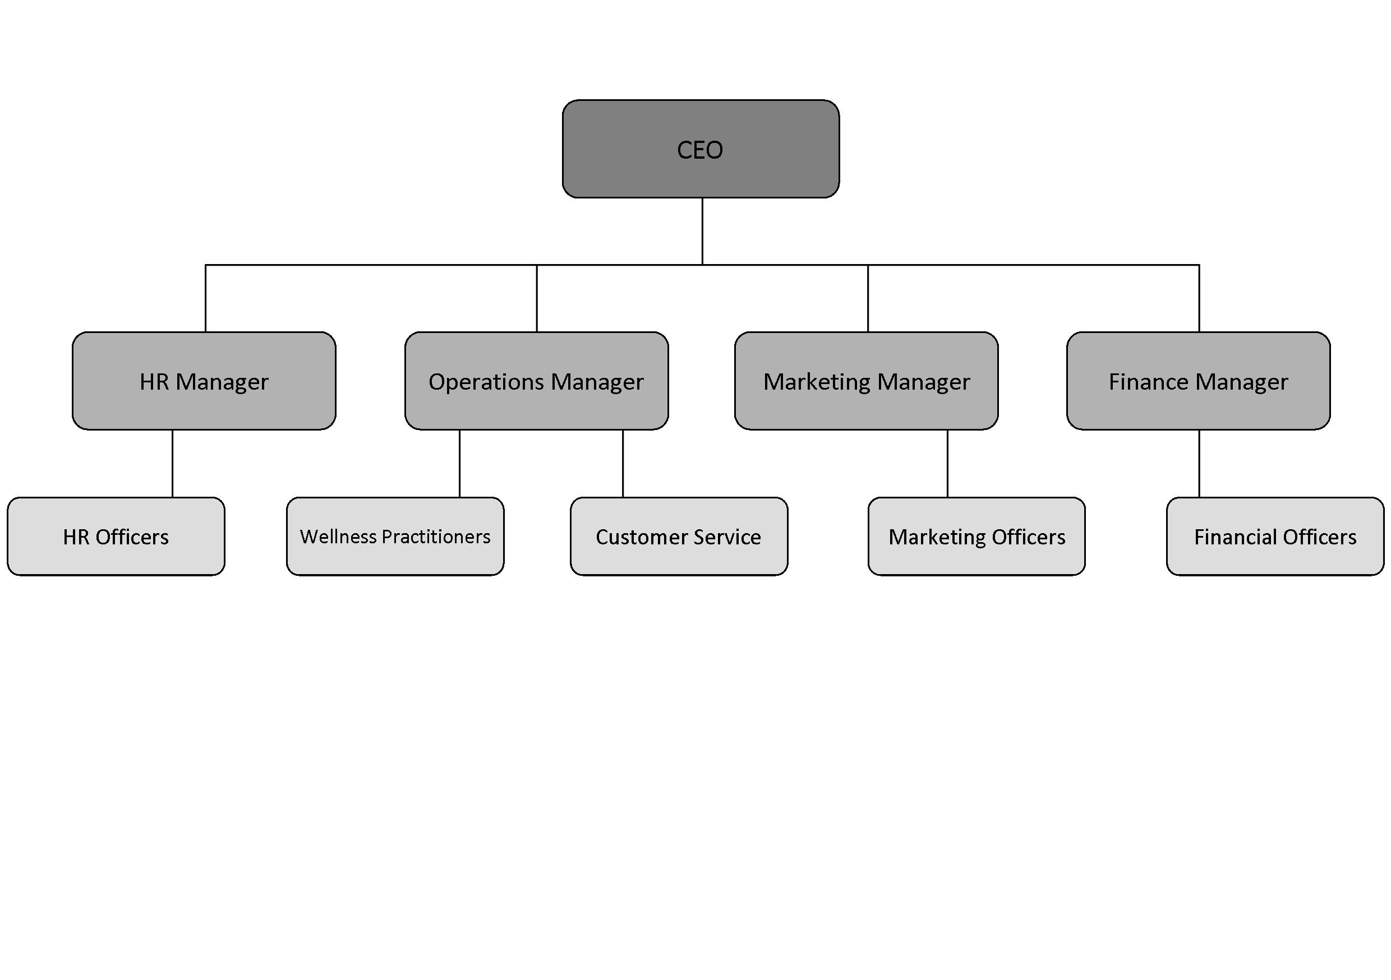**Organisational Structure**

SUPPORTING DOCUMENT (D): TRANQUILITY WELLNESS CENTRE INDUSTRY RESEARCH

**Industry Research**

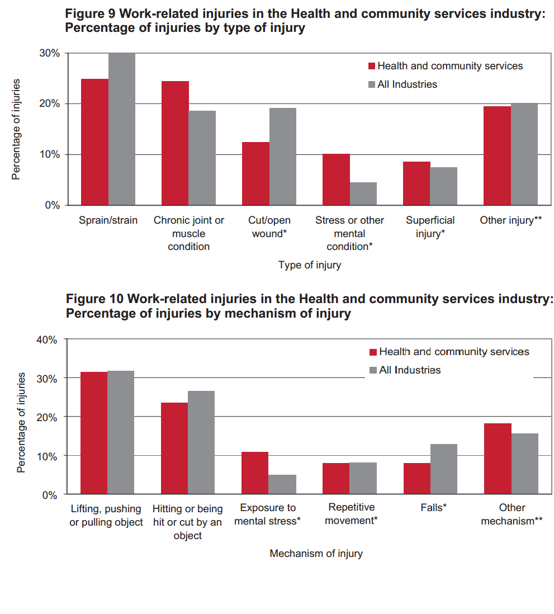

Safe Work Australia. 2014. “Work related Injuries 2005-2006: Health and Community Services.” Accessed on September23, 2014. http://www.safeworkaustralia.gov.au/sites/swa/about/publications/pages/ sr200910wrihealthandcommunity2005to2006