Module 3 Week 4 Lesson 13 SDL

- What is Fleming's Left-Hand Rule used for?

- Which finger represents the direction of the magnetic field in Fleming's LH Rule?

- How do you determine the direction of the current in Fleming's LH Rule?

- What does the thumb indicate in Fleming's LH Rule?

- In what kind of electrical device is Fleming's LH Rule commonly used?

- How are the directions of magnetic force, magnetic field, and current related to each other in Fleming's LH Rule?

- How can you determine the direction of motion of a conductor using Fleming's LH Rule?

- A wire moves to the right in a magnetic field directed upward. The current flows from left to right in the wire. Determine the direction of the magnetic field using.

- A conductor moves upward in a magnetic field, and the direction of motion is towards the left. If the magnetic field is directed into the page, determine the direction of current flow in the conductor using Fleming's LH Rule.
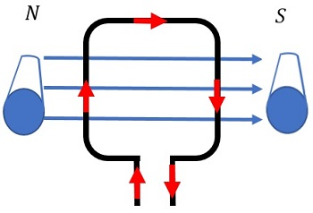
- In the diagram, we are looking down on the setup. The current is moving clockwise around the coil. Which way does the coil rotate?

