Module 7 Week One Lesson 3 SDL

Complete the quiz to assess your measuring skills.

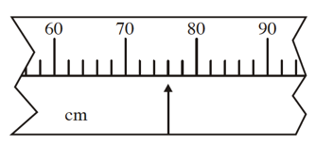
- Write the measurement indicated by the arrow in cm.

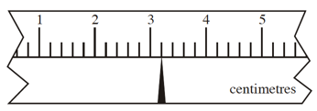
- Write the measurement indicated by the arrow in cm.

- Rank the following wire diameters from largest to smallest:
0.156 0.109 0.0625 0.016
- Show these measurements on the ruler with the letter and an arrow: A 5.9 cm B 7 mm

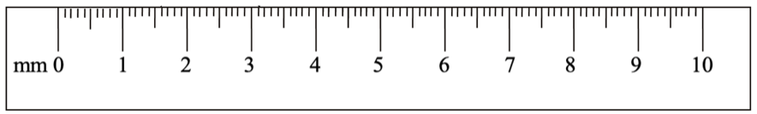
- Find the lengths of the line segments.  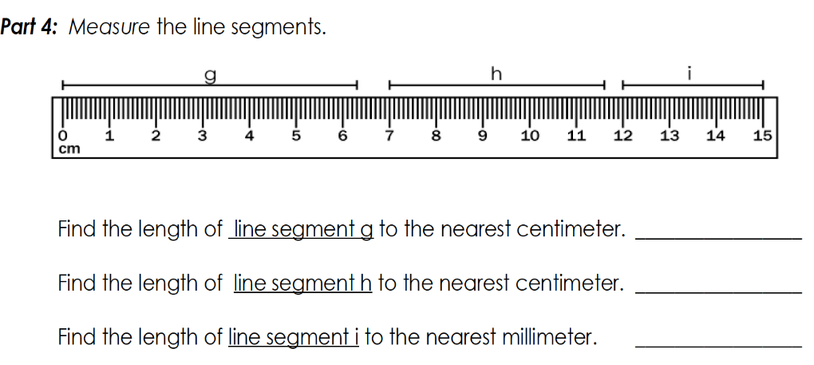 | g = ____ to nearest cm  h = ____ to nearest cm  i = ____ to nearest mm
- Write this measurement as a decimal number in cm.
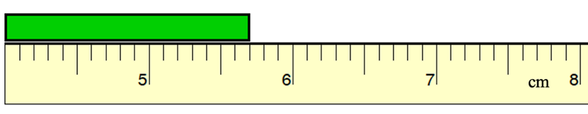
- Write this measurement in fraction form.
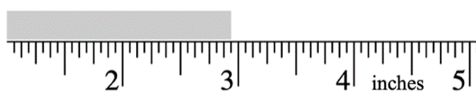
- Write this measurement as a decimal in mm.
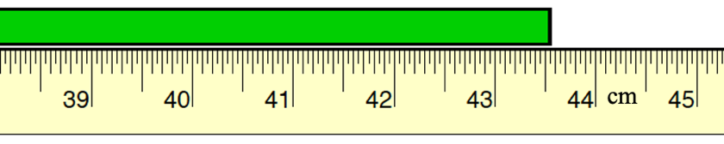
- Write this measurement as a decimal in cm. 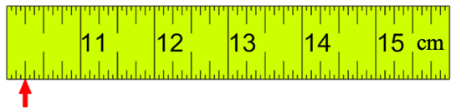
- Put the following drill bits in order from largest to smallest:
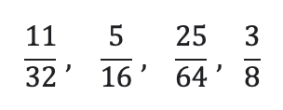
- Write this measurement in fraction form.
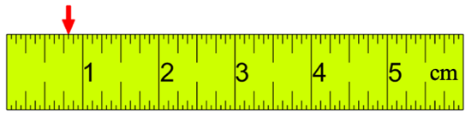
- Write this measurement as a decimal in cm.
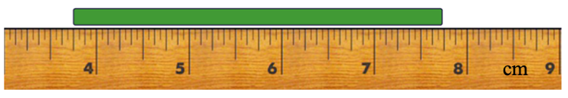
- Write this measurement as a fraction in inches.
