Learning Activity: NZST Tours

Advertisement:

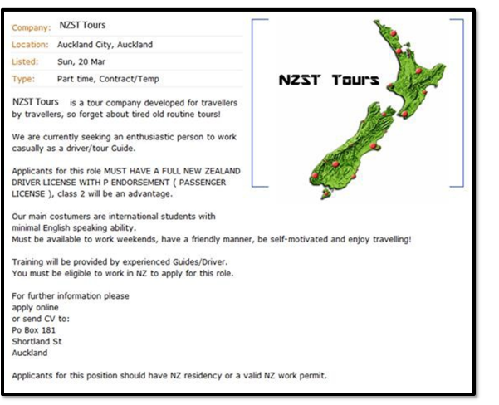

Complete the following table and post it to the Forum as specified in your learning material.

|  |  |
| --- | --- |
| **Competencies** | *What competencies are needed to drive the bus?* |
| **Skills** | *What skills does the driver of the bus need?* |
| **Capabilities** | *What capabilities must the driver possess?* |