**Module 3 Activity Worksheet 17**

|  |
| --- |
| Why is Voltage Drop important? |
|  |
|  |
|  |

|  |  |
| --- | --- |
| List three factors that would increase Voltage Drop. | |
| 1. |  |
| 2. |  |
| 3. |  |

Calculate the voltage drop in this example from the video, as a **percentage** of the nominal voltage at the point of supply.

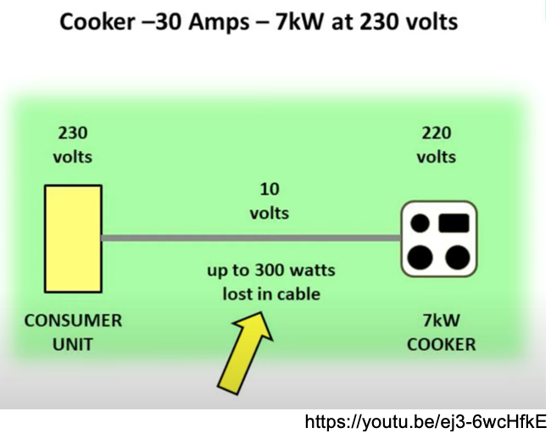

**Calculation**

Use the formula above and the values from Table C8 to answer the following questions.

|  |
| --- |
| 1. Calculate the percentage voltage drop in a 50m run of 16mm2 cable carrying three-phase (400V) 32A. |

|  |
| --- |
| Did you calculate answers of 0.97% (2 d.p.) and 25mm2 ?  What would your answer to Question 1 be if the supply was single-phase 230V? |