Soil Field Test Record Sheet
Date | 2 February 2023 | Name | Chris Kura
Location | 123 Kaupapa Street, Tokomaru, Horowhenua | Most recent rainfall (mm) | 6mm, 24 hours ago

Soil horizon | Top (cm) | Bottom (cm) | Depth of horizon (cm) | Texture | Structure | Observations* | Photo
Organic layer | 0 | 8 | 8 | Organic | Good | Medium brown. Lots of large roots and organic matter. Soil feels light and spongy. Broken glass and pottery found. | 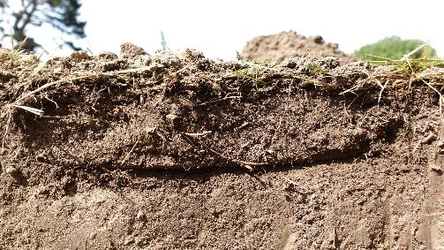
Topsoil | 8 | 25 | 17 | Silt | Good | Medium-light brown. Easy to dig. Good structure, smaller roots till present. Broken glass found. | 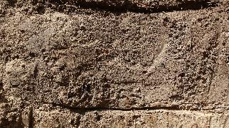
Subsoil | 25 | - | - | Clay | Poor | Very light brown with orange mottling (spots). Very hard, compressed structure. Some small roots resent in the top 10cm. | 