*Spirited Away* worksheet

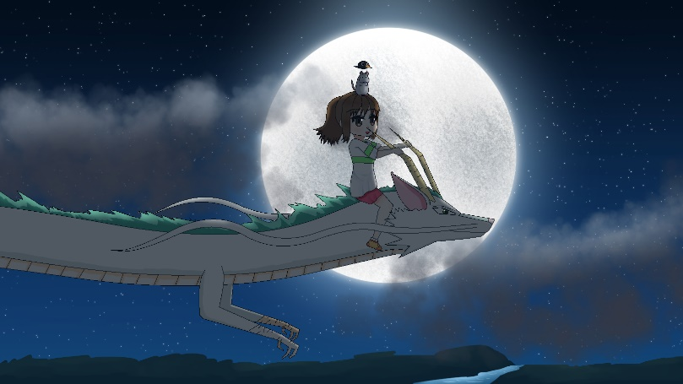

Use this worksheet to record your findings from each of the two learning tasks in the **Fundamental Narrative and Storytelling Concepts** subtopics.

Remember to save your worksheet to your device. Doing so will ensure you don’t lose work before you post it to your forum thread in **Forum: Visual Storytelling**.

Contents

1. Complete story treatment components for *Spirited Away* 2

Title: 2

Logline: 2

Plot summary: 2

Major characters: 3

Setting: 3

2. Explain the three-act narrative structure of *Spirited Away* 4

Act 1: 4

Act 2: 4

Act 3: 5

## 1. Complete story treatment components for *Spirited Away*

### Title:

### Logline:

### Plot summary:

### Major characters:

### Setting:

## 2. Explain the three-act narrative structure of *Spirited Away*

### Act 1:

### Act 2:

### Act 3:

|  |
| --- |
| **NOTE:** |
| After recording your findings in this worksheet, go back to the **Final Image** module and share your completed worksheet to your forum thread in **Forum: Visual Storytelling**. |