Sportique Pty Ltd Practice Exercise
- Use the Error Checking function to check for errors in the worksheet.
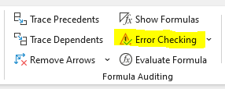
Provide a screenshot of any formulas that you identify as incorrect.
Formulas you identified as incorrect
Did you identify the following errors?
Cell F16
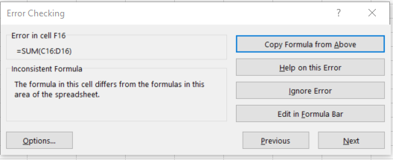

Cell H12
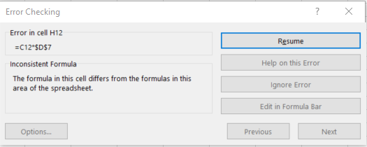
Cell G14
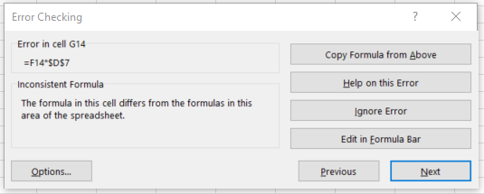

Correct the errors and save the file.

