Project Management Fundamentals

Participant Manual - Activities

Swinburne Professional  
Education for Working Professionals

PO Box 218, H69  
Hawthorn VIC 3122

**P** 1800 633 560  
**E** indenrolments@swin.edu.au  
**W** www.swinburne.edu.au/professional/

These materials have been developed for the use of the Swinburne University of Technology. Swinburne reserves the right to cancel, suspend or modify the materials.

CRICOS 00111D – TOID/RTO 3059

The materials may not be duplicated without the written agreement of Swinburne Professional, Swinburne University of Technology, PO Box 218, H69, Hawthorn 3122 – Phone 1800 633 560 – Email swinburneprofessional@swin.edu.au

Version 2.2 – 11 September 2018

© September 2018 – All Rights Reserved

Contents

Contents 3

Course Project 4

Project Management 6

Activity: What are the outcomes? 8

Activity: Who are your stakeholders? 8

Activity: Engaging stakeholders 9

Activity: Your sticky notes 11

Activity: Defining your resources 13

Activity: Identifying the messages 15

Activity: Who needs what? 15

Activity: Your vision 16

Activity: Addressing resistance 17

End of Day One 18

Activity: Stating their roles 21

Activity: Getting the skills 22

Activity: How will you monitor? 22

Activity: Handover to the business 25

Activity: Thank you and celebration 25

Activity: Effective evaluation 26

Activity: How did you go? 27

Reflection and Plan 28

Notes and Ideas 29

Appendix A: Gantt Chart Template 32

Appendix B: RACI Matrix 33

Appendix C: Return on Investment (ROI) 34

References 35

Course Project

Moving a Corporate Office

AlphaBeta Corporation is a supplier of consulting services and products to government and private industry. It has experienced considerable growth in the last 12 months, going from 80 employees to 150. This growth means that their current corporate offices are no longer adequate for their needs; four months ago they rented additional space across the road for 45 staff. Further to this, they anticipate that the organisation will continue to grow to possibly 200 people within the next 18 months, possibly reaching 280 in the next five years to align to their Strategic Plan to expand their corporate offerings and market share.

As a result of this situation, the Executive and Board of AlphaBeta have decided to relocate their corporate offices to a new location. The new site has already been chosen, it is 20 minutes out of the city, and will comfortably support their anticipated growth for the next five years.

The organisation has appointed a dedicated Project Manager and team to manage the Corporate Relocation Project. The project is responsible for:

* Ensuring that the new corporate offices are appropriately designed and set up to support the needs of the organisation – including offices and other working spaces; reception; meeting rooms and AV; break areas and equipment; other facilities (restrooms, first aid, stationery storage etc.); ICT cabling and other requirements; document and records storage. Their remit also includes: interior design choices, OHS compliance of spaces and furniture, and a range of requirements for break areas and other employee concerns.
* Identifying all items that **will be moved** into the new facility, and organising the removals processes.
* Identifying all items that **will not be moved** to the new facility, and organising disposal, sale or donation of these items.
* Organising the make good handover of the current facility back to the landlord, and finalising the leases on the main corporate office and the temporary space across the road.
* Ensuring business continuity throughout the move.
* Communicating and engaging staff in the process.

The Executive are anticipating that this will take six months to complete, but they have not authorised a final budget at this stage.

The Project Team consists of:

* Project Manager
* Business Analyst
* Change/Communications Manager
* Five Project Officers.

The project reports to a Relocation Steering Committee, and a business reference group is being established to ensure that the requirements and concerns of the five business units are factored into the low-level decisions.

While you will be working on the entire project for the scoping document, you will need to focus on one aspect of the project for the project plan development. In your group, you need to identify which aspect of the project you will focus on for the detailed tasks. Suggestions include:

* the fit out of the new corporate office
* the removal and make good of the current corporate offices
* selection and procurement of external design services and OHS compliance of products
* design and delivery of the meetings rooms and associated AV.

You will need to confirm this with your facilitator.

1.1.2 Project Management

In your small group, consider the questions below and write down your responses on post-it-notes (one response per post-it-note).

* Place your post-it-notes on the appropriate flip chart paper on the wall.
* Use the space below to record your responses for future reference.

What is a project?

What is project management?

What makes a project succeed?

What makes a project fail?

What do project managers manage?

1.1.4 Activity: What are the outcomes?

Using the Project agreed upon in your group, define at least two Outcomes for your project.

1.1.4 Activity: Project goal

Using your Project, develop a SMART project goal that will help achieve your outcome above.

1.1.4 Activity: Who are your stakeholders?

Using the agreed project and the template on the next page, come up with the list of stakeholders for your project. Complete the Name, Overview, Must haves and support columns in the table – the idea is to come up with a description about what their stake in the project is, what they might want to see included and their perceived level of support.

* For support they are either: Strongly Against (SA), Against (A), Neutral (N), Supportive (S), Strongly Supportive (SS).
* Then, decide which quadrant your stakeholders are in and put that in the Influence column. Use the quadrant numbers to make it easier.

1.1.4 Activity: Engaging stakeholders

Considering their influence, how will you engage with them? Do they need the ability to contribute? If so, what is your Engagement strategy? Complete the Engagement column in the table.

Remember: the engagement plan is more than only communication. It might include other activities like site visits, demonstrations, training etc.

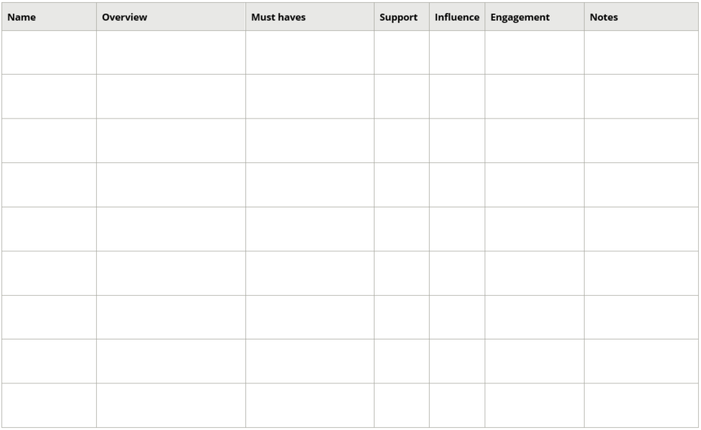

1.1.5 Activity: Your sticky notes

Watch the video Project Planning with Sticky Notes (https://youtu.be/80c-LRRJ0W8) and try it for yourself using your Project:

* You will need: flip chart paper, post-it-notes, textas and sticky tape.

My insights

1. Plan with your team – start with the project name and brief them into the activity
2. Brainstorm work packages – get the group to do a sticky for each activity or deliverable they can think of
3. Group work packages into streams – structure the sticky notes into groups of activities/tasks and give the stream a name
4. Check for completeness – review using the 100% rule, whether you have included all required deliverables for the complete product/system/service
5. Check for clarity – confirm understanding, renaming packages or streams to make it clearer if required
6. Keep a record – take a photo or the structure on paper.

1.1.5 Activity: Create your Gantt chart

In your group, run an abbreviated process for your project and create your Gantt chart (use Gantt chart template below – there is another copy in your appendices).

|  |  |  |  |  |  |  |  |  |  |  |  |  |  |  |  |  |  |  |  |  |
| --- | --- | --- | --- | --- | --- | --- | --- | --- | --- | --- | --- | --- | --- | --- | --- | --- | --- | --- | --- | --- |
| **Project Manager:** |  | **Version Control:** |  | | | | **Project Name:** | | | |  | | | | | **Date Revised/ Updated:** |  | | | |
| **Item No** | **Activity/ Task** | **Duration** | **Jan** | **Feb** | **Mar** | **Apr** | **May** | **Jun** | **Jul** | **Aug** | **Sep** | **Oct** | **Nov** | **Dec** | **Who** | **Resources**  **(people, equip)** | **KPI’s** | **Dependency** | **% Complete** | **Risk/s** |
|  |  |  |  |  |  |  |  |  |  |  |  |  |  |  |  |  |  |  |  |  |
|  |  |  |  |  |  |  |  |  |  |  |  |  |  |  |  |  |  |  |  |  |
|  |  |  |  |  |  |  |  |  |  |  |  |  |  |  |  |  |  |  |  |  |
|  |  |  |  |  |  |  |  |  |  |  |  |  |  |  |  |  |  |  |  |  |
|  |  |  |  |  |  |  |  |  |  |  |  |  |  |  |  |  |  |  |  |  |
|  |  |  |  |  |  |  |  |  |  |  |  |  |  |  |  |  |  |  |  |  |
|  |  |  |  |  |  |  |  |  |  |  |  |  |  |  |  |  |  |  |  |  |
|  |  |  |  |  |  |  |  |  |  |  |  |  |  |  |  |  |  |  |  |  |
|  |  |  |  |  |  |  |  |  |  |  |  |  |  |  |  |  |  |  |  |  |
|  |  |  |  |  |  |  |  |  |  |  |  |  |  |  |  |  |  |  |  |  |
|  |  |  |  |  |  |  |  |  |  |  |  |  |  |  |  |  |  |  |  |  |

1.1.5 Activity: Defining your resources

Using the template on the next page, define your resources for your Project. Where you are unsure of costs, make a best guess for now – you could try Google for a general idea, depending on what it is.

|  |  |  |  |  |  |  |
| --- | --- | --- | --- | --- | --- | --- |
| WBS Package | Activity | Resources needed | Dates needed | Time  (days/weeks) | Estimated costs | Actual costs |
|  |  |  |  |  |  |  |
|  |  |  |  |  |  |  |
|  |  |  |  |  |  |  |
|  |  |  |  |  |  |  |
|  |  |  |  |  |  |  |
|  |  |  |  |  |  |  |

1.1.5 Activity: Identifying the messages

Using your Project, what are the key messages for your stakeholders? Define three key messages that incorporate the need for the change, benefits of change and at least one action they need to take.

You then need to understand what sort of communications you are going to develop and who needs which messages, and when.

1.1.5 Activity: Who needs what?

Using your stakeholder analysis and the key messages outlined above, provide a brief overview of the communication plan for your Project. *Note: the what is the general topic of the communications, in a large project you might develop a list of all the What’s first before you start this process.*

|  |  |  |  |
| --- | --- | --- | --- |
| **To whom** | **What**  **e.g. status report, next step msg, overview, why the change etc.** | **Method**  **e.g. email, phone, meeting** | **When/ How often** |
|  |  |  |  |
|  |  |  |  |
|  |  |  |  |

Once you have developed this outline, you would include each of these communication requirements in your project schedule/Gantt chart. These are usually grouped together, but it’s important to include them in case a piece of communication relies on an activity being completed. If it’s not together, then you run the risk of not updating communication dates when deliverable dates change.

Remember, to support your positive change, people need to have trust and confidence in the project.

1.1.6 Activity: Your vision

Using the agreed Project, develop the vision for change in your project.

*Change is an organisational activity – transition is an individual process to adapt to the change.*

1.1.6 Activity: Addressing resistance

Your facilitator will give you two causes to discuss. Looking at why people resist, can you come up with a couple of methods to help you guide people through this resistance? Share with the group.

1.1.7 End of Day One

Take a moment to list the three most valuable things you took from today – an idea, a method, a resource. Include a brief explanation of where you plan to use it back in your workplace.

|  |
| --- |
|  |
|  |
|  |

1.1.8 Activity: Start the risk process

Using your Project, develop a list of six potential risks, use at least a couple of the categories above. In the following table, evaluate their Consequence/Likelihood and decide on a course of action to mitigate them.

|  |  |  |  |  |  |  |  |  |
| --- | --- | --- | --- | --- | --- | --- | --- | --- |
| Ref No. | Risk | Result | C | L | R | Risk Mitigation Action | Responsible | Date |
|  |  |  |  |  |  |  |  |  |
|  |  |  |  |  |  |  |  |  |
|  |  |  |  |  |  |  |  |  |
|  |  |  |  |  |  |  |  |  |
|  |  |  |  |  |  |  |  |  |
|  |  |  |  |  |  |  |  |  |
|  |  |  |  |  |  |  |  |  |

1.1.9 Activity: Stating their roles

Consider the information in your project plan – how can you use these resources to ensure your staff understand the purpose of the project and their roles and responsibilities delivering it?

As well as ensuring individuals understand their roles and responsibilities, it’s important to get the team working together as quickly as possible. You could use Tuckman’s team development model to help move your team to the Performing stage – which is where you need them to be.

1.1.9 Activity: The Challenge

Participate in “The Challenge” and as the group debrief occurs, record your insights below

My insights

1.1.9 Activity: Team dynamics and my current (work) project

From a team dynamic perspective, what does this mean for the Project Manager and for project success?

1.1.9 Activity: Getting the skills

Review your Project and list the specialist skills you might require to deliver your project. How would you bring those skills into your team? Consider consultants, other staff in the organisation, training etc.

| **Skills** | **Who and/or How** |
| --- | --- |
|  |  |
|  |  |
|  |  |
|  |  |
|  |  |
|  |  |
|  |  |

1.1.9 Activity: How will you monitor?

Using your Project, develop a basic outline of how you will monitor your project. Show that you have thought about the deliverables, milestones, budget, resources, risks and issues.

1.1.9 Activity: What to do?

Scenario One

You’re a month out from the deadline of your first major milestone and a team member has just informed you that the external contractor has contacted them about a significant issue. The key personnel for the contractor has resigned; as a result, they will not be able to complete the work in the required three weeks – they anticipate it will be six weeks before another staff member can come up to speed and complete the task. What do you do? How could this have been avoided?

Scenario Two

You are three months into the implementation of your nine month project and you have just been advised that a major organisational change project has slipped six months in delivery. This means the delivery of the new system, and month of organisation-wide training is now scheduled to occur over your delivery dates. It also means that two key staff who were going to be available for the last three months of your project, to help writing procedures and an online training module, will no longer be available. What are your options? Should you change your project?

Scenario Three

Your Project Sponsor, a member of the Executive Team, has been telling you that there is great support from all members of the Executive for your project. But, a colleague from another part of the business has just told you they overheard the Director of Operations telling one of his reports that the project is pointless and will never be completed if he has anything to say about it. Since Operations are a significant stakeholder in your project, you need to make sure they are supportive and engaged with the change. What should you do? Could this have been avoided?

1.1.10 Activity: Handover to the business

You have to pull together the documents and other paperwork for a handover to the business owner. What will you include? What is essential for them to have to hand? What else needs to be done?

1.1.10 Activity: Thank you and celebration

Your project has been running for 11 months, with a project team that has subject matter experts from across the business, a working group and a team of change champions. In your group, come up with some suggestions on how you will close out your project, thank everyone and celebrate your success.

|  |  |  |
| --- | --- | --- |
| **Close** | **Team** | **Supporting staff** |
|  |  |  |

1.1.10 Activity: Effective evaluation

You’re about to conduct the evaluation on your project. What information would you use? Who needs to be involved? Who needs to know the outcome?

|  |  |  |
| --- | --- | --- |
| **What** | **Who** | **Who needs the report?** |
|  |  |  |

1.1.10 Activity: How did you go?

You are completing the evaluation for your Office Relocation Project. While the staff were in their new office by the required date, it took three weeks longer than expected to complete the “make good” on the old offices – which incurred additional rental costs.

As well as this, there were 4-6 week delays in completing the setup of the new AV in the meeting rooms, because of timing conflicts with the contractors. There were also a number of plumbing issues in the new kitchen areas which took about a month to completely resolve.

These delays did not increase the project costs, but there were three minor WHS incidents because of the AV cabling/equipment occurring around employees, and a major slipping incident in one of the kitchenettes.

How would you capture these outcomes? What might you learn from them to share with others? Create the other details you require.

1.1.10 Reflection and Plan

|  |  |
| --- | --- |
| What will I ***start*** doing? How will I know?  *(Priority order with timeframes)* | What will I ***stop/improve?*** How will I know?  *(Priority order with timeframes)* |
|  |  |
|  |  |
|  |  |
|  |  |

Who might I talk to for support or assistance?

|  |
| --- |
|  |

What do I want to find out more about?

|  |
| --- |
|  |

Notes and Ideas



Appendix A: Gantt Chart Template

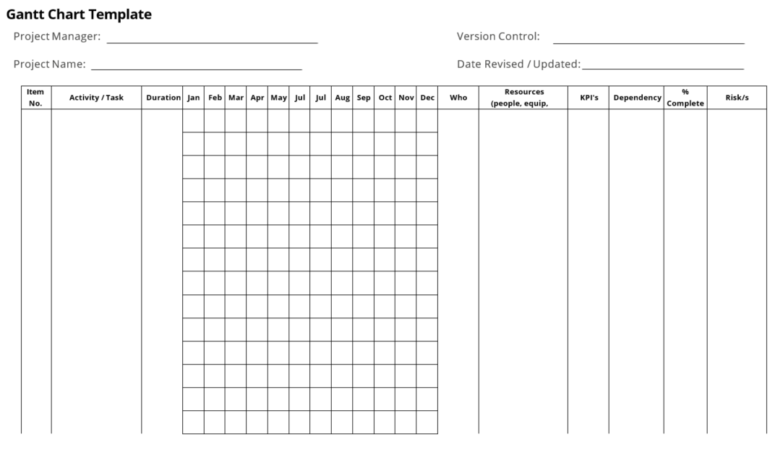

Appendix B: RACI Matrix

Project governance accountabilities

Many projects run into trouble because they do not have clear accountabilities. To resolve this, you can define your governance accountabilities in the form of a RACI matrix.

A RACI (Responsible, Accountable, Consulted, Informed) matrix describes how the project roles are involved in the delivery of tasks, activities and deliverables.

* Responsible – the role(s) who will do the work to achieve the task.
* Accountable – the role with ultimate responsibility for the completion of the task or deliverable. There can only be one accountable person per task or deliverable.
* *Support – Depending on the project, you could also include Support and create a RASCI matrix.*
* Consulted – the people whose opinions are sought, usually experts.
* Informed – the people who need to be kept up-to-date on the progress or completion of the task or deliverable.

It might look like this:

|  |  |  |  |  |  |  |
| --- | --- | --- | --- | --- | --- | --- |
| **Tasks** | **Project Sponsor** | **Project Manager** | **Project Officer** | **Business Analyst** | **IT Manager** | **Finance Officer** |
| Approval of funding | AR | R |  |  | C | C |
| Finalisation of Business Requirements document |  | A | R | R | C |  |
| Development of Tender Plan | I | AR | R | I | C | R |

Some basic guidelines for the matrix are:

* The left-hand column can be defined in many different ways – project tasks, deliverables, work packages, stages, functions and so on.
* Accountability is where the buck stops. If something goes awry, this person is held to account.
* But, they may delegate to someone else – in which case that other person is Responsible.
* There should ideally only be one Accountable (A) in any row, to avoid buck-passing.
* One person may be both Accountable and Responsible (AR).
* Multiple people may be Responsible i.e. authority may be delegated to several people.
* ‘Consult’ means two-way communication – we are seeking feedback, input, opinion, advice.
* ‘Inform’ means one-way communication – we are pushing information out and not seeking anything back.
* As such, it makes no sense to have both C and I in any one box.
* Not every box needs to be filled.

Appendix C: Return on Investment (ROI)

There are a number of ways to measure the ROI of your project. Some organisations require you to calculate the Net Present Value (NPV) or Internal Rate of Return (IRR) as a means of deciding whether to proceed with the work. We’re going to focus on something far simpler than that, but you should check this with your organisation.

ROI = (Change in Operational Costs - Costs of Project) / Cost of Project

ROI = (Change in Revenue - Costs of Project) / Cost of Project

**Costs of Project:** Capture the total cost of the project, both the external and internal expenses. This would include things like: salaries, on-costs, service costs (IT, office space etc.), consultants, procurement, service contracts, insurances etc.

**Operational Costs:** Capture all changes in operational costs based on your project. This would include things like: contracts and licensing you no longer have to pay, changes in amount of materials required, changes in time taken (as a salary figure), changes in cost of materials, any ongoing expenditure of the project (licences, insurances etc.), etc. Note: not all these will be a reduction and some of them are difficult to calculate.

**Revenue:** Capture all changes to the organisation’s revenue relating to the project. This is self-evident and of course you could have Operational Cost savings alongside Revenue.

Most organisations consider ROI over a number of years, since it is often unrealistic to consider that a project will break even with its expenditure in the first year of implementation – and a project that introduces a significant organisational change may take a number of years to break even. This is often done over five years, depending on the size of the project.

For example, our project costs are $55,000 and we’ve calculated that the annual saving to the organisation is $25,000, but in the first year we’ll only realise half of that saving:

|  |  |  |  |
| --- | --- | --- | --- |
|  | **Project Costs** | **Operational Savings** | **ROI** |
| Year 1 | $55,000 | $12,500 | -$42,500 |
| Year 2 |  | $37,500 | -$17,500 |
| Year 3 |  | $62,500 | $7,500 |
| Year 4 |  | $87,500 | $32,500 |
| Year 5 |  | $112,500 | $57,500 |

You can see we will break even during Year 3 and after five years this project would realise a $57,500 return on investment – or using the calculation above:

($112,500 - $55,000) / $55,000 = 104.5% at the five year mark.

References

Cole K, 2016, *Management Theory and Practice Edition 6,* Cengage Australia

Dobie C, 2007, *A Handbook of Project Management: A Complete Guide for Beginners to Professionals*, Allen & Unwin, Australia

Gibbons P, 2015, *The Science of Successful Organizational Change: How Leaders Set Strategy, Change Behavior, and Create an Agile Culture*, Pearson Education

Hartley S, 2009, *Project Management Principles, Processes and Practice 2nd Ed*., Pearson Prentice Hall, Australia

Harvard Business Review, 2012, *Guide to Project Management,* Harvard Business Review Press

Project Management Institute, 2017, *A Guide to the Project Management Body of Knowledge (PMBOK® Guide)*, Sixth Edition

Online Resources

*Project Planning with Sticky Notes*: https://youtu.be/80c-LRRJ0W8

Tasmanian Government, *Project Management*, www.egovernment.tas.gov.au/project_management

